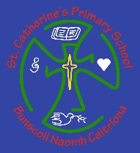
St. Catherine’s Primary School

Online Safety Newsletter

October 2020

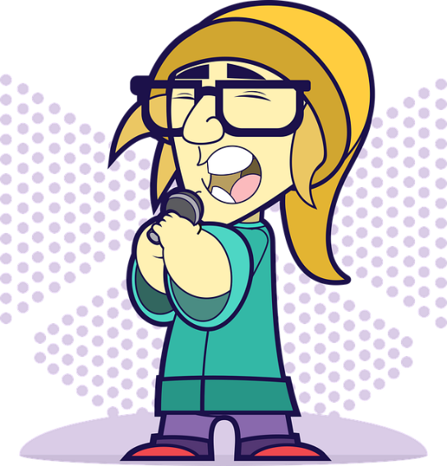
Triller

What is Triller?
Triller is a social video platform available for iOS and Android users. It has been widely compared to TikTok as it involves users dancing or lip-synching to their favourite songs. A number of celebrities are using Triller such as Justin Bieber and Rita Ora. Users can create videos, which are then auto-edited along with the ability to add filters and personalise with text and emojis.

Triller is rated as 12+ by the App store, which means it may not be suitable for children under the age of 12.

What should I be aware of?
Reporting/Blocking:
If your child does come across any inappropriate content or behavior then they can report it within the app by tapping on the three dots within the user’s profile. They can also choose to block that user. Alternatively, you can email support@triller.co.
Saving:
Users are able to share other people’s videos (via other social media platforms/ email/ messages/by downloading) which means somebody could share your child’s video without their consent. It is important your child is aware of this.
Inappropriate content:
Whilst Triller state in their Community guidelines that harmful content is not allowed and will be removed, potentially inappropriate content could be viewed.
Direct messages/commenting
There is the ability to privately message other users as well as receive comments on your videos. This can pose a risk of receiving negative messages.
In app purchases:
‘Gold’ can be bought as an in-app purchase. Ensure your card details are not saved on your child’s device and that your child understands to always ask permission before purchasing.

Public profiles:
You need an account to upload content. When you create an account, it is automatically set to public. Accounts can be changed to private in profile settings, which means only the people your child approves, can view what they upload.

Further information

As always, have regular chats with your child about what they are doing online. It’s really important to make sure that your child knows that they should talk to you or another trusted adult if they have any concerns. You can find out more about Triller here:
- Community Guidelines: https://www.triller.co/resources/index.html
- Triller FAQ: https://www.triller.co/faq/index.html
- What is Triller article? https://www.saferinternet.org.uk/blog/what-triller
Users of this guide do so at their own discretion. No liability is entered into. Current as of the date released 1.10.20.

Reels
Instagram
Supporting your child with gaming

This is a fantastic resource to help you support your child whilst gaming. It includes tips on how to help your child stay safe and how to set boundaries as well as signposting to further organisations if you require further support.

https://youngminds.org.uk/find-help/for-parents/parents-guide-to-support-a-z/parents-guide-to-support-gaming/

What is Instagram Reels?
This is Instagram’s latest feature and is being portrayed as Instagram’s version to TikTok. Users will now be able to create 15-second videos using filters and music. Reels follows your privacy settings on Instagram so if your child has a public account then anybody will be able to view their reels. Users can share their reel to the ‘Explore’ tab where it can be seen by the wider Instagram community or it can be shared with their followers by on their Feed.

Further information
Do you own a Smart Speaker?

Have you set up appropriate safety settings for your Smart speaker? Find out more here:

https://www.internetmatters.org/resources/smart-speakers-set-up-safe-guide/

You can find out more about Instagram Reels here:
- https://about.instagram.com/blog/announcements/introducing-instagram-reels-announcement
- https://www.net-aware.org.uk/news/what-is-instagram-reels/

Online Hate Crimes

What are Online Hate Crimes?
A Hate crime describes an incident or crime that takes place against someone based on a part of their identity e.g. their race or ethnicity or their religion. Online Hate Speech is viewed very seriously by the Police and those who post hate crime can be charged, which may lead to a criminal record and potentially a prison sentence.

TikTok in the news

You may have saw recently in the news, a story circulating about some distressing content that was being circulated on TikTok.

Thinkuknow have produced the following article which outlines what to do if your child has seen something inappropriate online.

https://www.thinkuknow.co.uk/parents/articles/what-to-do-if-your-child-has-seen-something-inappropriate-online/

What can I do?
If you see anything online that can offend or hurt somebody or you are a victim of an online hate crime then you can report it via that platform’s reporting process. If you wish to take the issue further and believe the content is illegal and originates in the UK then you can report it to the Police here: https://www.report-it.org.uk/reporting_illegal_online_hate_material_to_the_p.

Further information
You can find out more here:
- Hate Content: https://www.getsafeonline.org/protecting-yourself/hate-content/
- Young People’s Online Hate Resource Hub: https://www.stophateuk.org/onlinehate/
- Victim Support: https://www.victimsupport.org.uk/crime-info/types-crime/hate-crime

