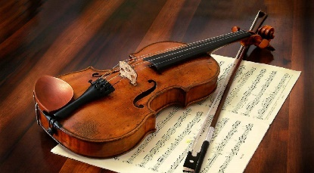
EA Music Services
Music Unlocked
Dear Parents/Guardians,
As you are all aware our children have suffered greatly due to the impact of the Corona Virus this school year and one of the many disappointments was the interruption of instrumental training and vocal coaching for those KS2 children.
We have received an update from the Music Service management team, which we would like to share with you. It gives details of the provision of a set of new pilot programmes for online learning. This service will offer communication links for support and advice on the safe delivery of instrumental and vocal lessons from tutors and the programmes will be delivered directly to pupils/parents in the form of either shared, pre-recorded tutorials or live online lessons.
More importantly, their first priority, when they return to operational status, is to issue REFUNDS to schools and parents for any shortfall of Music Service delivery for the academic year 2019-2020.
To find more information and to contact Music Service staff, you can access the updated website:
https://www.eani.org.uk/services/music-service
These pilot programmes will be offered based on availability of resources and will be free of charge. Tutors participating in the pilot programmes will identify pupils/parents to take part.

“To inspire, support and challenge all our Children and Young People to be the best that they can be”

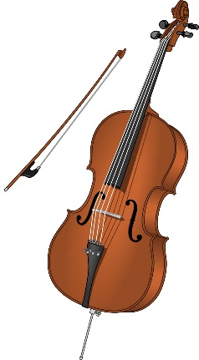
Thank you so much for your patience and continued support for what is and will be a very valued service for our children going forward,
Mrs Dolores Doherty- Music leader
