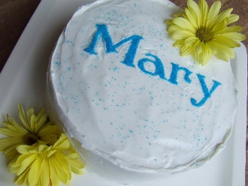
Announcing …….The Great Diocese Bake Off!
In honour of May is the Month of Mary

We know that lots of you have been baking , Therese in our Catechetical Centre has challenged us- staff, parents, family members, principals to bake cakes, cupcakes, cookies or decorate cakes you have in the house or create model cakes out of materials you have in the house or draw a cake for Mary-whatever is possible for you.
Please send your entries to ddcc@derrydiocese.org
and forward them on to Saint Catherine’s Facebook page.

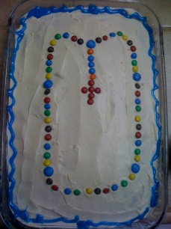
God bless

Happy Baking!

