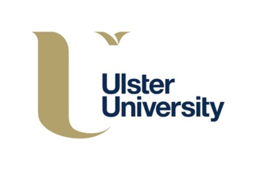
Dear Parent/Guardian,

NI parents’ views sought on experience of remote schooling during COVID-19

Ulster University researchers are seeking the views of parents of children from all kinds of schools across Northern Ireland on their experience of supporting their children’s learning during the coronavirus (COVID-19) pandemic and invite you to take part in this research.

The pandemic has led to school closures across the world. Local schools closed on 20 March with an expectation for children to learn at home with their parents. The team of researchers from the UNESCO Centre, School of Education at Ulster University will explore how parents or guardians of primary school children, post-primary school children and children at special schools are guiding and supporting their child/children’s learning, and the support they receive from schools, teaching staff and the wider community. The research is designed to highlight the challenges and the benefits that parents have experienced in supporting their children’s learning at this time, in order for the education system to be better prepared for any similar challenges in the future.

The short surveys are available open for responses until 15 May and can be accessed via:

Survey for parents of primary school children in Northern Ireland:
https://www.surveymonkey.co.uk/r/primaryparentsNI

Survey for parents of post-primary school children in Northern Ireland:
https://www.surveymonkey.co.uk/r/postprimaryparentsNI

Survey for parents of children who attend special schools in Northern Ireland:
https://www.surveymonkey.co.uk/r/specialschoolsparents

Many thanks for considering this request,

Dr Una O’Connor Bones (Principal investigator), email: ub.oconnor@ulster.ac.uk
Dr Jessica Bates, email: j.bates@ulster.ac.uk
Jayne Finlay, email: j.finlay@ulster.ac.uk
Dr Stephen Roulston, email: s.roulston@ulster.ac.uk
Sammy Taggart, email: s.taggart@ulster.ac.uk

UNESCO Centre, School of Education, Ulster University, Coleraine Campus, BT52 1SA.
Text Message NI parents views sought on experience of remote schooling during COVID-19:open until 15 May: @ https://www.surveymonkey.co.uk/r/primaryparentsNI

