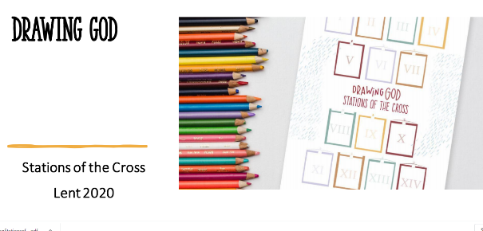
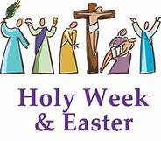

Hi Parents
Drawing God “The Stations of the Cross” is a brilliant art activity for Easter. The children have listened to the story “Drawing God” by Karen Kiefer in school and many have already been involved in “Drawing God”
We would love parents to have a look at this new Easter resource, based on the book and get their children involved in drawing some of the stations of the cross for Easter. Parents can forward on their children’s artwork to Therese Ferry who works at our catechetical centre in Derry and also to Saint Catherine’s Facebook page,
The Irish Catholic Newspaper got in touch with Therese about the Drawing God Stations of the Cross Project. They are going to do an article next week on it and want pictures from children. Parents please email your children's Station of the Cross art to
tferry@derrydiocese.org
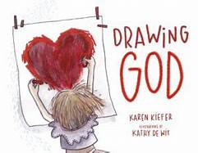
include their name and school on the email please
This is just a beautiful art project to be involved in

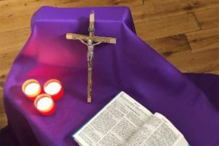
At the link below you will also find loads of Easter ideas to help during this Holy Time. These resources will be updated regularly and will include resources for Religious Education and Faith Formation. These are from our catechetical centre Derry.
https://catecheticalcentre.org/category/primary-school-resources/

