PATHS Programme in St. Catherine’s
(Promoting Alternative Thinking Strategies)

PATHS Quote of the_Month June

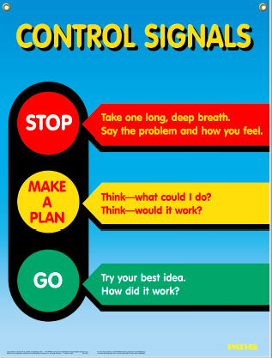
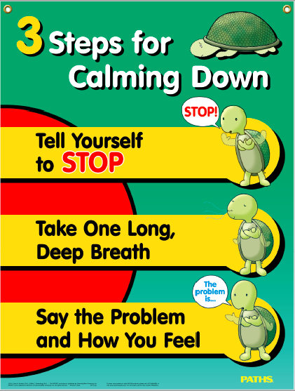
There are comfortable and uncomfortable feelings.
Remember all feelings are okay
Now is a good time to use your Control Signals and Three Steps for Calming Down if you have uncomfortable feelings

Be kind
Listen to your Parents/Guardians
Show love

