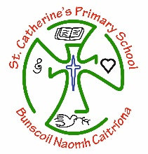
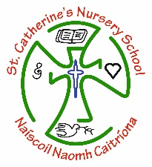

P6 Summer Packs for Transfer Tests – Learning Together

Dear Parent/Guardian,
We hope you are all well and continuing to keep safe.
With schools not returning until September and the revised dates for the Transfer Tests having been released, Learning Together have been working on their packs for the summer months. These packs are priced at £3.00 per pack.

If you are interested in ordering a pack (optional) please email you child’s teacher by Wednesday 20th May 2020.

Contact email:

P6a: Mr McGuigan amcuigan559@c2kni.net

P6b: Mrs Deery cdeery318@c2kni.net

P6c : Miss Keyes ekeyes746@c2kni.net
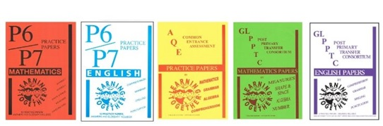

Take care and stay safe,

Year 6 team
Mr McGuigan, Mrs Deery & Miss Keyes

