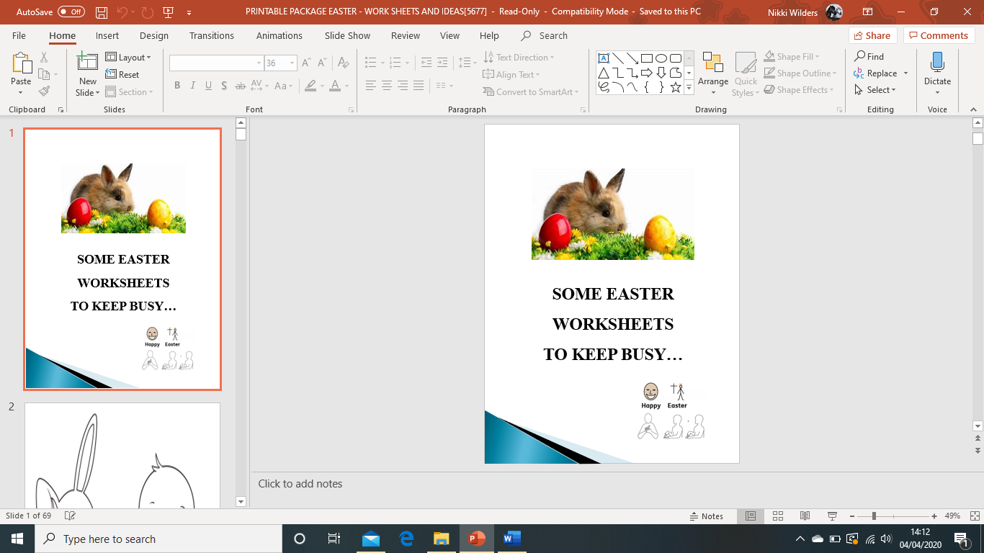

[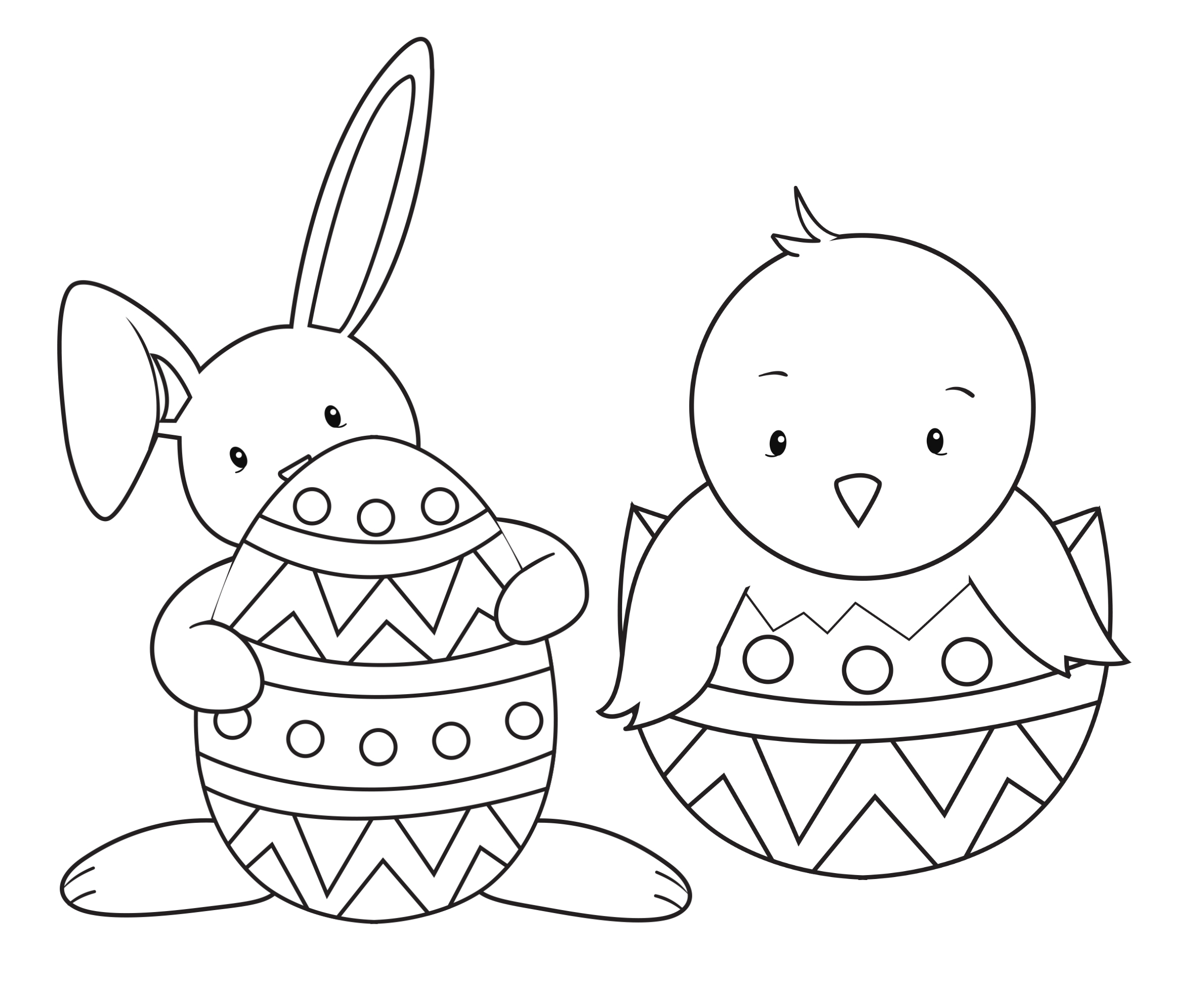](https://www.google.co.uk/url?sa=i&url=https%3A%2F%2Fcrazylittleprojects.com%2Feaster-coloring-pages%2F&psig=AOvVaw2EbtCnatbWeNAy3gcT32nW&ust=1585988649753000&source=images&cd=vfe&ved=0CAIQjRxqFwoTCLCV-b7qy-gCFQAAAAAdAAAAABAH)

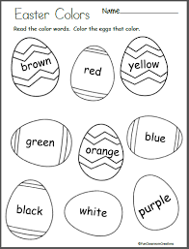

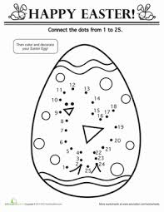

[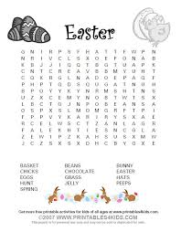](https://www.google.co.uk/url?sa=i&url=https%3A%2F%2Fwww.pinterest.com%2Fpin%2F413627547021624881%2F&psig=AOvVaw2nRZ64TmQTazOoivl6b2mR&ust=1585989596048000&source=images&cd=vfe&ved=0CAIQjRxqFwoTCMCv_fHty-gCFQAAAAAdAAAAABAG)

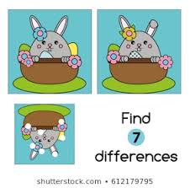

[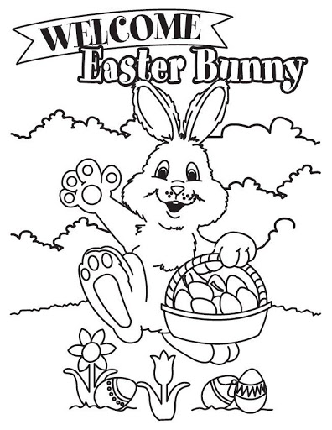](https://www.google.co.uk/url?sa=i&url=http%3A%2F%2Fclipart-library.com%2Fclipart%2F19-BzTXppRiB.htm&psig=AOvVaw2nRZ64TmQTazOoivl6b2mR&ust=1585989596048000&source=images&cd=vfe&ved=0CAIQjRxqFwoTCMCv_fHty-gCFQAAAAAdAAAAABAO)

[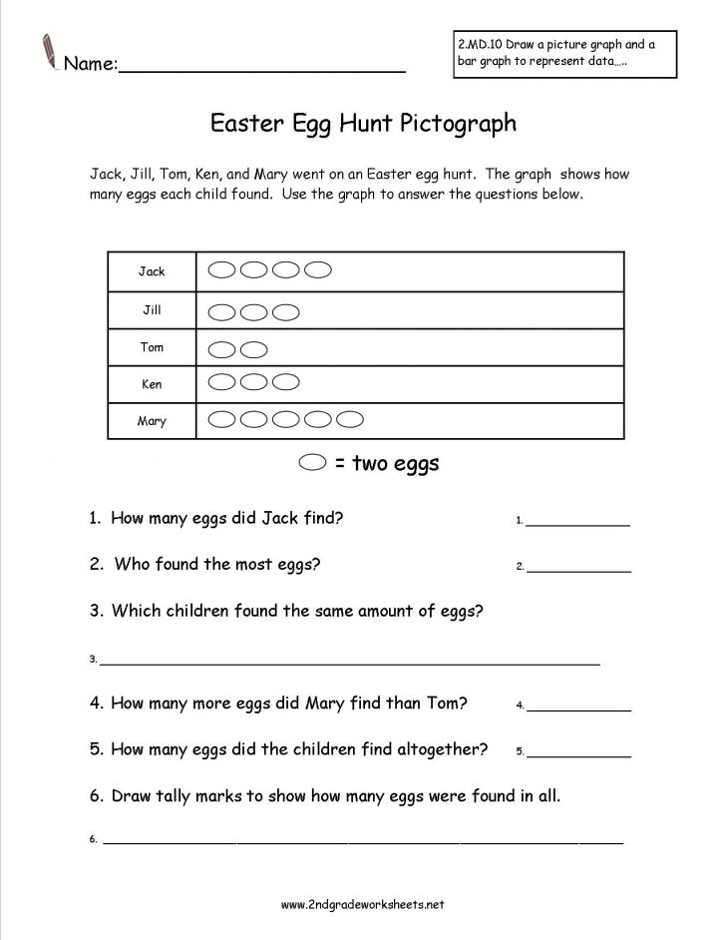](https://www.google.co.uk/url?sa=i&url=http%3A%2F%2Fwww.jtnproadrunner.org%2Fmarvelous-reading-test-worksheets-photo-ideas%2Freading-comprehension-testworksheet-family-esl-worksheet-3%2F&psig=AOvVaw2nRZ64TmQTazOoivl6b2mR&ust=1585989596048000&source=images&cd=vfe&ved=0CAIQjRxqFwoTCMCv_fHty-gCFQAAAAAdAAAAABAV)

[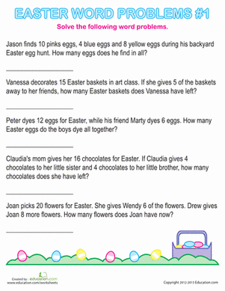](https://www.google.co.uk/url?sa=i&url=https%3A%2F%2Fwww.education.com%2Fslideshow%2Feaster-word-problems%2F&psig=AOvVaw2nRZ64TmQTazOoivl6b2mR&ust=1585989596048000&source=images&cd=vfe&ved=0CAIQjRxqFwoTCMCv_fHty-gCFQAAAAAdAAAAABA4)

[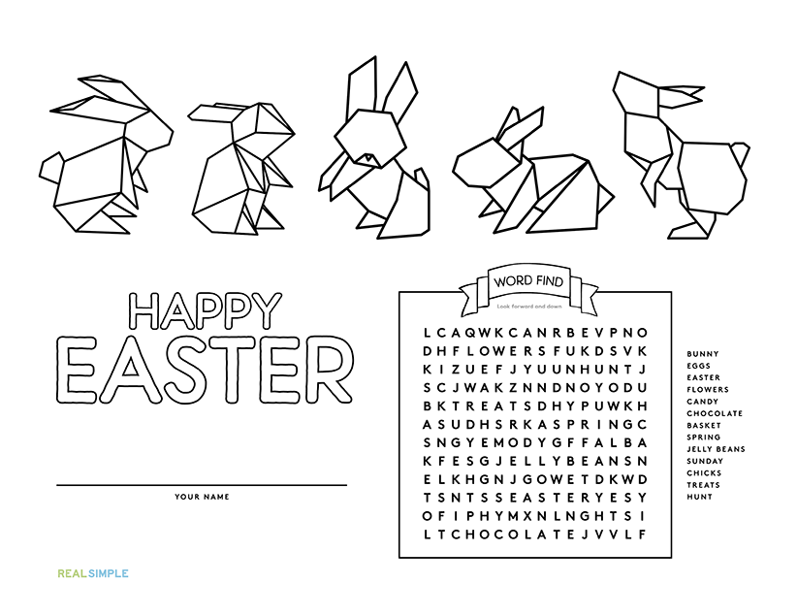](https://www.google.co.uk/url?sa=i&url=https%3A%2F%2Fwww.realsimple.com%2Fholidays-entertaining%2Fholidays%2Fmore-holidays%2Fprintable-easter-placemats&psig=AOvVaw2nRZ64TmQTazOoivl6b2mR&ust=1585989596048000&source=images&cd=vfe&ved=0CAIQjRxqFwoTCMCv_fHty-gCFQAAAAAdAAAAABBE)

[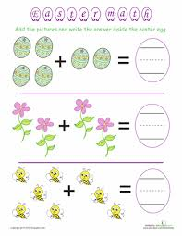](https://www.google.co.uk/url?sa=i&url=https%3A%2F%2Fwww.pinterest.com%2Fpin%2F51580358204296236%2F&psig=AOvVaw3fg2giO3lMmzeYy4F086uJ&ust=1585990454162000&source=images&cd=vfe&ved=0CAIQjRxqFwoTCKDf7oDxy-gCFQAAAAAdAAAAABAT)

[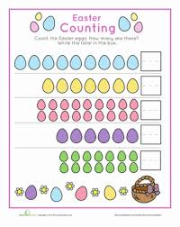](https://www.google.co.uk/url?sa=i&url=https%3A%2F%2Fwww.pinterest.com%2Fpin%2F116601077831281725%2F&psig=AOvVaw3fg2giO3lMmzeYy4F086uJ&ust=1585990454162000&source=images&cd=vfe&ved=0CAIQjRxqFwoTCKDf7oDxy-gCFQAAAAAdAAAAABAY)

[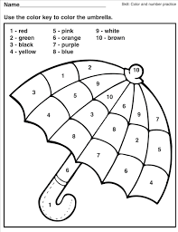](https://www.google.co.uk/url?sa=i&url=http%3A%2F%2Fdayanandwebb.com%2F2y24d6vw3%2FnM23648rD%2F&psig=AOvVaw0JOT3sZZgj49KvjWZfextu&ust=1585990572007000&source=images&cd=vfe&ved=0CAIQjRxqFwoTCKje9Lrxy-gCFQAAAAAdAAAAABAD)

[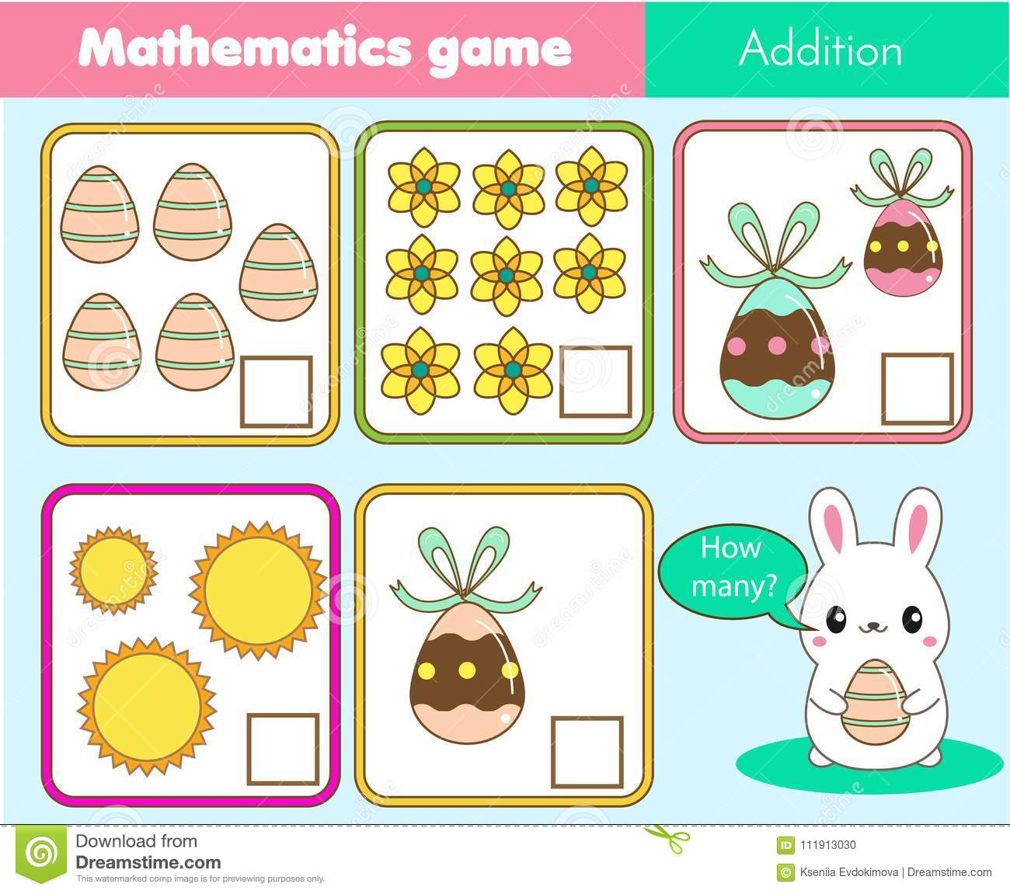](https://www.google.co.uk/url?sa=i&url=https%3A%2F%2Fwww.dreamstime.com%2Fcounting-educational-children-game-math-kids-activity-how-many-objects-task-easter-theme-addition-worksheet-easter-game-counting-image111913030&psig=AOvVaw0JOT3sZZgj49KvjWZfextu&ust=1585990572007000&source=images&cd=vfe&ved=0CAIQjRxqFwoTCKje9Lrxy-gCFQAAAAAdAAAAABAP)

[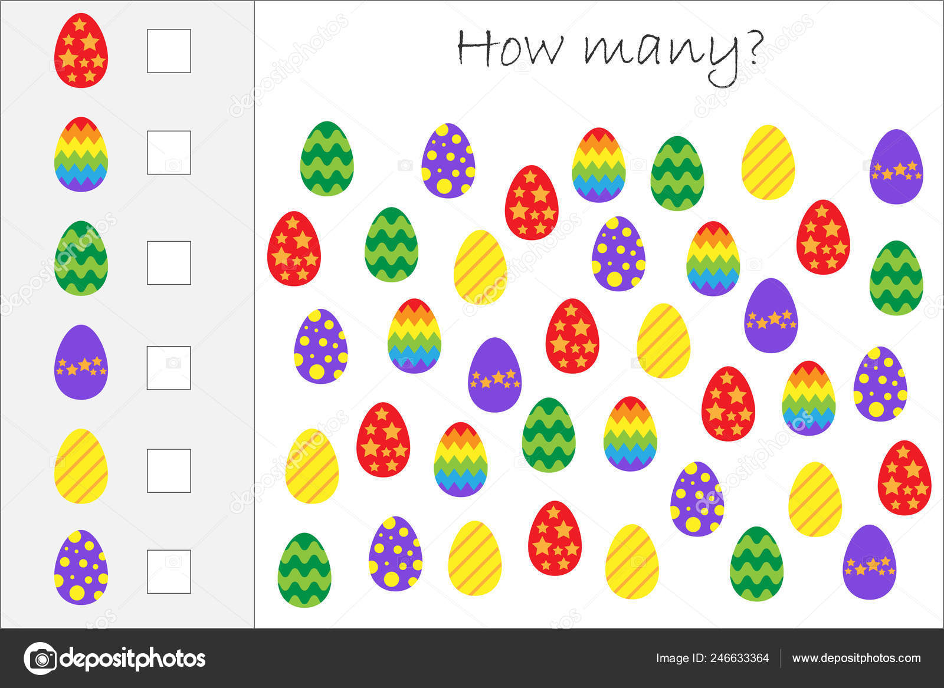](https://www.google.co.uk/url?sa=i&url=https%3A%2F%2Fdepositphotos.com%2F246633364%2Fstock-illustration-how-many-counting-game-easter.html&psig=AOvVaw0JOT3sZZgj49KvjWZfextu&ust=1585990572007000&source=images&cd=vfe&ved=0CAIQjRxqFwoTCKje9Lrxy-gCFQAAAAAdAAAAABAb)

[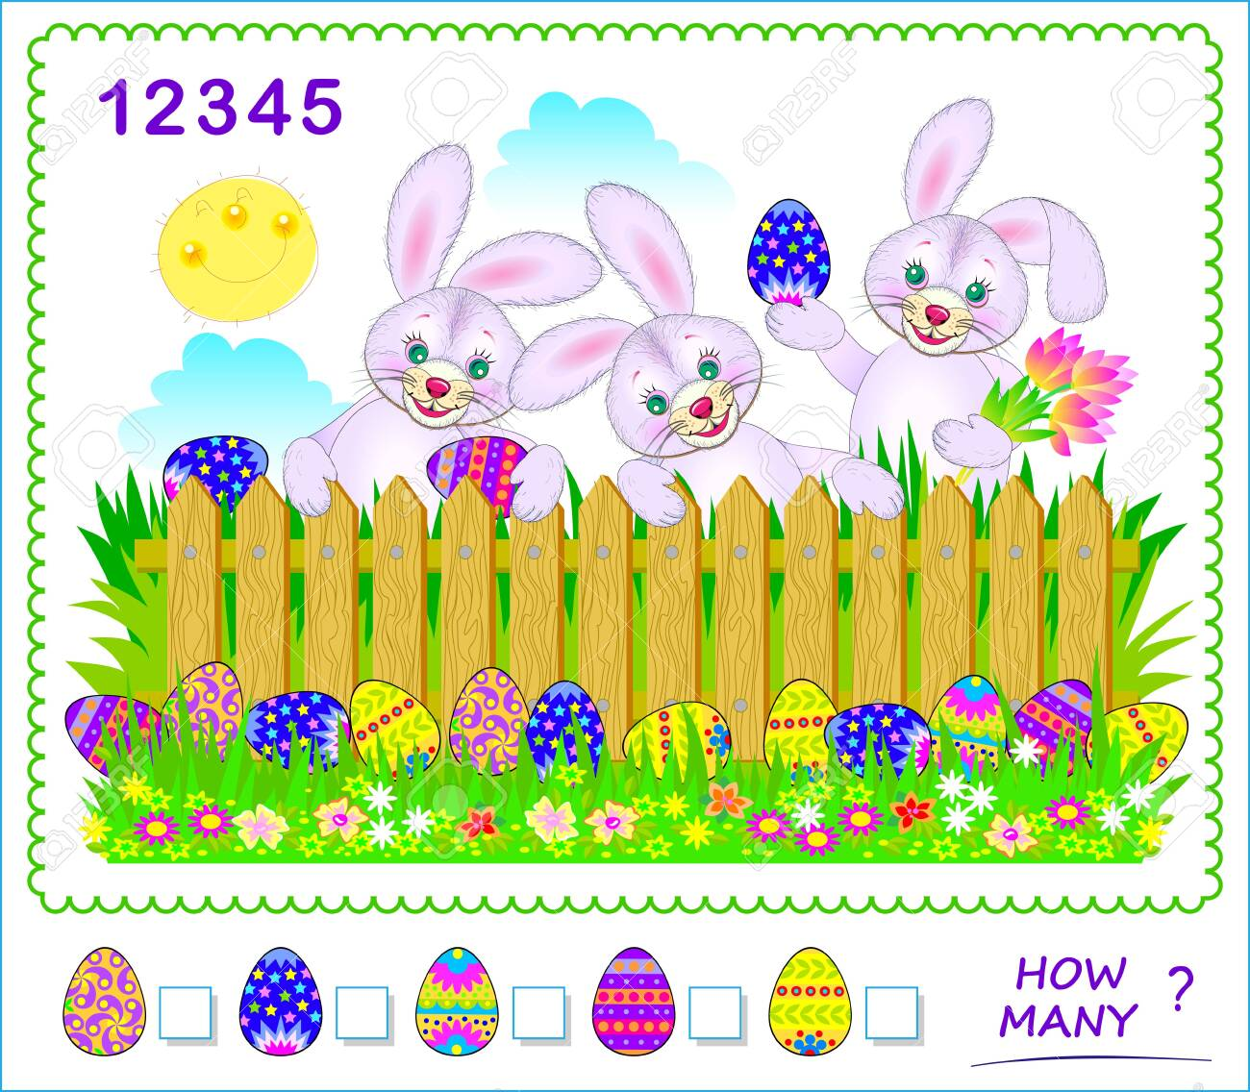](https://www.google.co.uk/url?sa=i&url=https%3A%2F%2Fwww.123rf.com%2Fphoto_138595650_stock-vector-math-education-for-children-how-many-easter-eggs-can-you-find-count-quantity-and-write-numbers-in-sq.html&psig=AOvVaw0JOT3sZZgj49KvjWZfextu&ust=1585990572007000&source=images&cd=vfe&ved=0CAIQjRxqFwoTCJCP2aDyy-gCFQAAAAAdAAAAABAS)

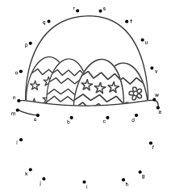

[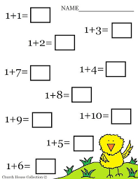](https://www.google.co.uk/url?sa=i&url=https%3A%2F%2Fwww.pinterest.com%2Fpin%2F297589487848756861%2F&psig=AOvVaw0JOT3sZZgj49KvjWZfextu&ust=1585990572007000&source=images&cd=vfe&ved=0CAIQjRxqFwoTCJCP2aDyy-gCFQAAAAAdAAAAABA3)

[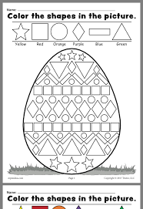](https://www.google.co.uk/url?sa=i&url=http%3A%2F%2Fgaffw.com%2F2484hn0dy%2FfB28423wJ%2F&psig=AOvVaw0JOT3sZZgj49KvjWZfextu&ust=1585990572007000&source=images&cd=vfe&ved=0CAIQjRxqFwoTCJCP2aDyy-gCFQAAAAAdAAAAABBA)

[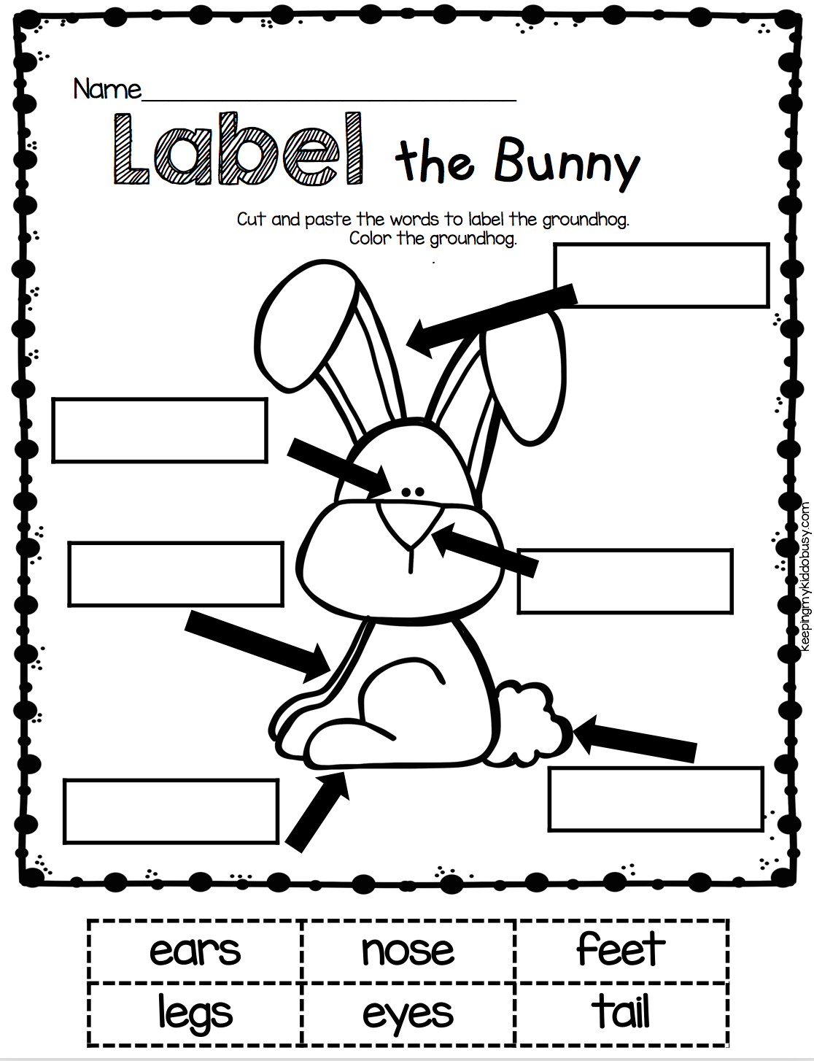](https://www.google.co.uk/url?sa=i&url=https%3A%2F%2Fdumpdominion.org%2Fprintable-kindergarten-worksheets%2Feaster-kindergarten-worksheets-best-coloring-pages-for-kids%2F&psig=AOvVaw0JOT3sZZgj49KvjWZfextu&ust=1585990572007000&source=images&cd=vfe&ved=0CAIQjRxqFwoTCJCP2aDyy-gCFQAAAAAdAAAAABBV)

[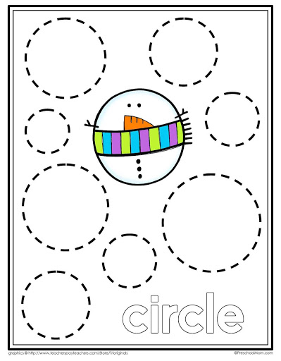](https://www.google.co.uk/url?sa=i&url=http%3A%2F%2Fgaffw.com%2F9k91uw2j8%2FnI18934dV%2F&psig=AOvVaw0JOT3sZZgj49KvjWZfextu&ust=1585990572007000&source=images&cd=vfe&ved=0CAIQjRxqFwoTCJCP2aDyy-gCFQAAAAAdAAAAABBc)

[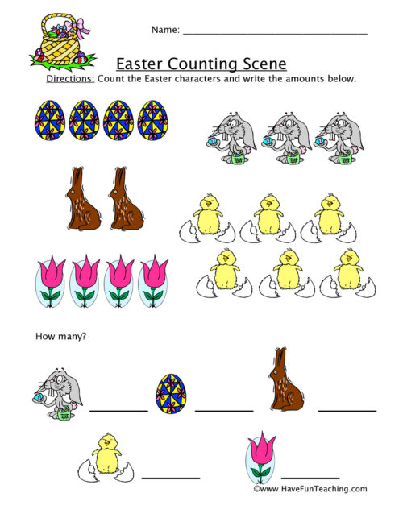](https://www.google.co.uk/url?sa=i&url=https%3A%2F%2Fwww.havefunteaching.com%2Fresources%2Fmath%2Fcounting%2Fworksheets%2F&psig=AOvVaw0JOT3sZZgj49KvjWZfextu&ust=1585990572007000&source=images&cd=vfe&ved=0CAIQjRxqFwoTCJCP2aDyy-gCFQAAAAAdAAAAABBx)

[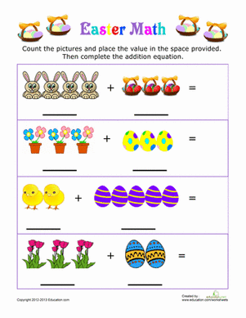](https://www.google.co.uk/url?sa=i&url=https%3A%2F%2Fwww.education.com%2Fworksheet%2Farticle%2Feaster-picture-addition%2F&psig=AOvVaw0JOT3sZZgj49KvjWZfextu&ust=1585990572007000&source=images&cd=vfe&ved=0CAIQjRxqFwoTCJCP2aDyy-gCFQAAAAAdAAAAABB-)

[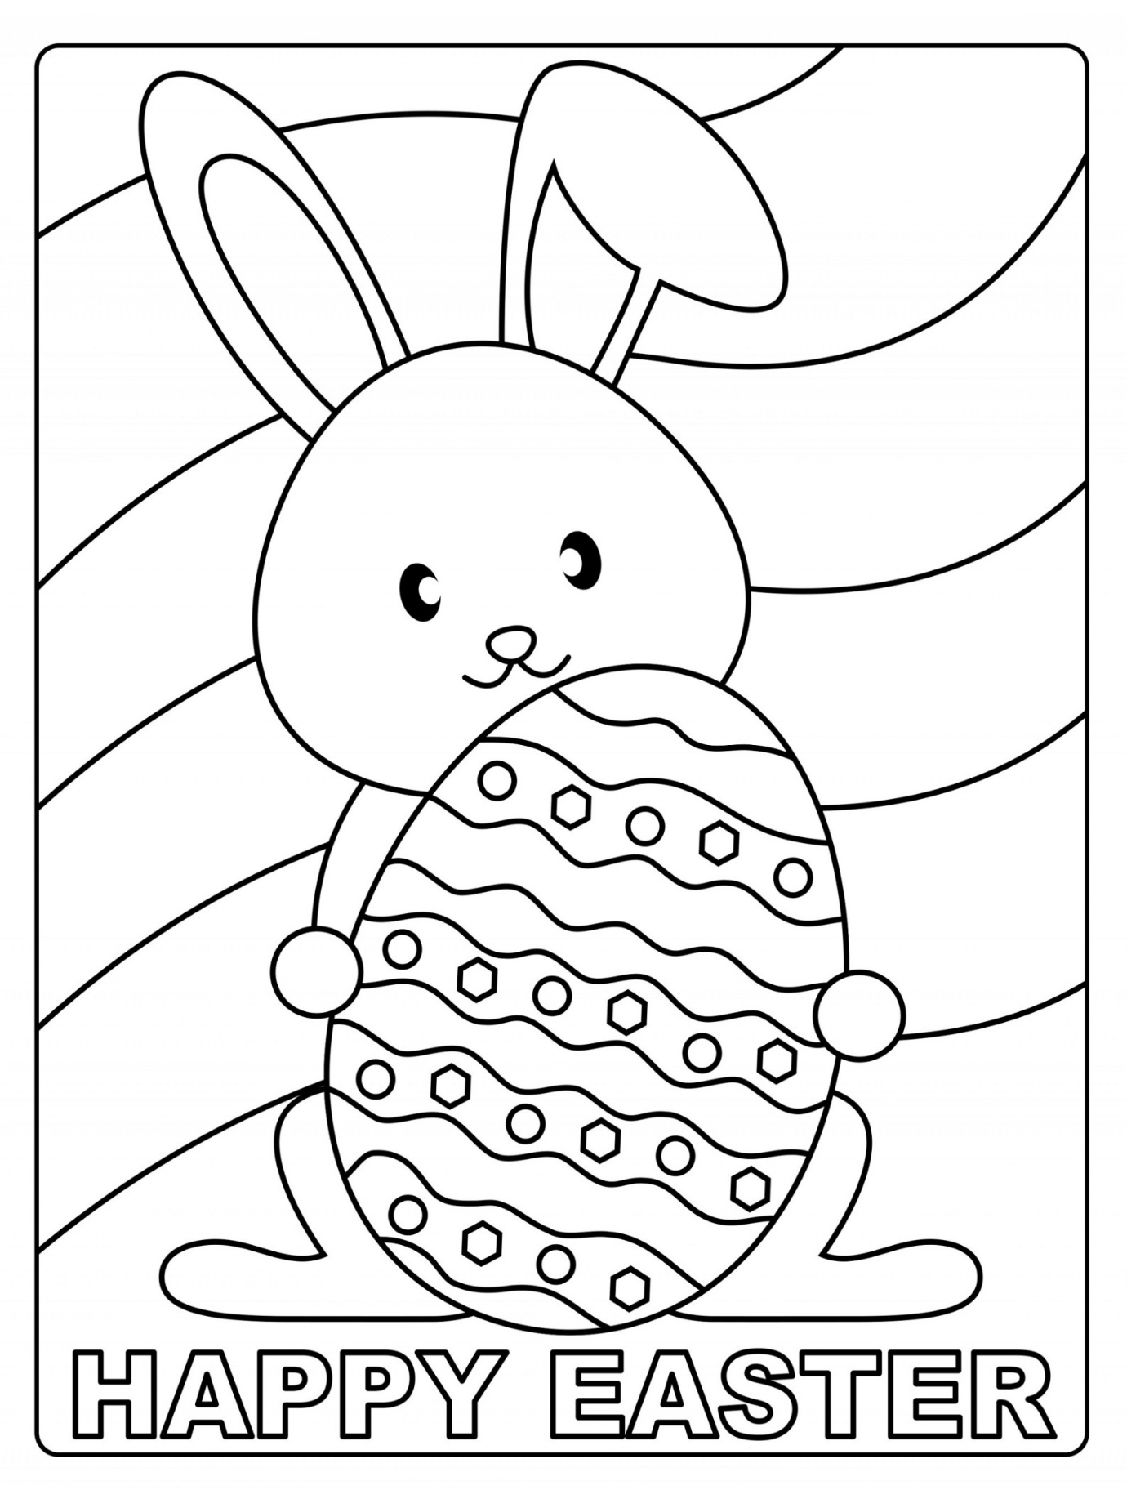](https://www.google.co.uk/url?sa=i&url=https%3A%2F%2Fwww.printableshelter.com%2Feaster-coloring-pages%2F&psig=AOvVaw3s68oUtOyd0DcrOzn98QTM&ust=1585991415816000&source=images&cd=vfe&ved=0CAIQjRxqFwoTCLCjjtD0y-gCFQAAAAAdAAAAABAU)

[](https://www.google.co.uk/url?sa=i&url=https%3A%2F%2Fwww.freeeasterprintables.com%2Fpreview%2FBig_Easter_Bunny_Coloring_Page&psig=AOvVaw0FWN4XNryAsgexIPRKabyM&ust=1585991540253000&source=images&cd=vfe&ved=0CAIQjRxqFwoTCOjRhYj1y-gCFQAAAAAdAAAAABAE)

[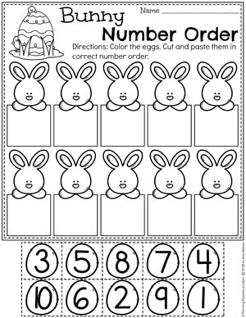](https://www.google.co.uk/url?sa=i&url=https%3A%2F%2Fplanningplaytime.com%2Feaster-worksheets&psig=AOvVaw0E2Qo5KIl2TUHlw2Vgbde1&ust=1585992013604000&source=images&cd=vfe&ved=0CAIQjRxqFwoTCLjiqej2y-gCFQAAAAAdAAAAABAS)

[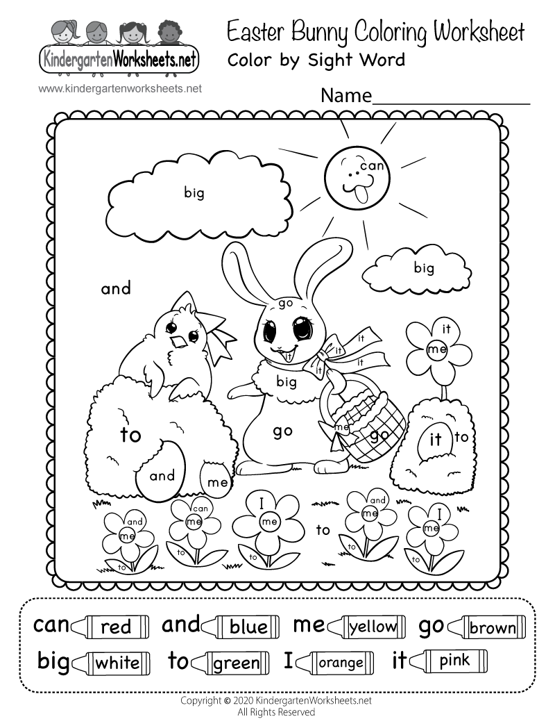](https://www.google.co.uk/url?sa=i&url=https%3A%2F%2Fwww.kindergartenworksheets.net%2Feaster-worksheets%2Feaster-bunny-coloring-worksheet.html&psig=AOvVaw0E2Qo5KIl2TUHlw2Vgbde1&ust=1585992013604000&source=images&cd=vfe&ved=0CAIQjRxqFwoTCLjiqej2y-gCFQAAAAAdAAAAABAY)

[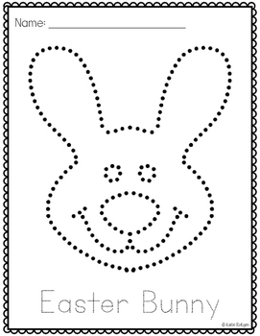](https://www.google.co.uk/url?sa=i&url=https%3A%2F%2Fwww.teacherspayteachers.com%2FProduct%2FEaster-Pinning-or-Tracing-Pages-2442933&psig=AOvVaw0E2Qo5KIl2TUHlw2Vgbde1&ust=1585992013604000&source=images&cd=vfe&ved=0CAIQjRxqFwoTCLjiqej2y-gCFQAAAAAdAAAAABAs)

[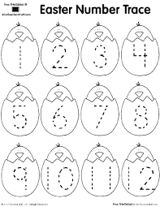](https://www.google.co.uk/url?sa=i&url=http%3A%2F%2Fprintables.atozteacherstuff.com%2F2425%2Fhatching-chick-number-trace%2F&psig=AOvVaw0E2Qo5KIl2TUHlw2Vgbde1&ust=1585992013604000&source=images&cd=vfe&ved=0CAIQjRxqFwoTCLjiqej2y-gCFQAAAAAdAAAAABAy)

[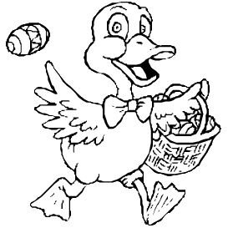](https://www.google.co.uk/url?sa=i&url=https%3A%2F%2Fwww.kidzone.ws%2Fmath%2Feaster-s%2Findex.htm&psig=AOvVaw0E2Qo5KIl2TUHlw2Vgbde1&ust=1585992013604000&source=images&cd=vfe&ved=0CAIQjRxqFwoTCLjiqej2y-gCFQAAAAAdAAAAABA4)

[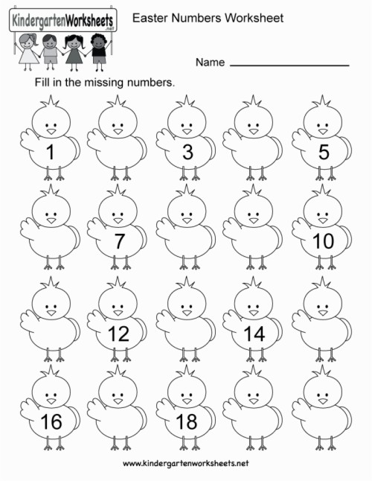](https://www.google.co.uk/url?sa=i&url=https%3A%2F%2Fwww.jakpost.travel%2Fvwall%2Fowwwix_easter-printable-activities-beautiful-easter-numbers-pre-k%2F&psig=AOvVaw0E2Qo5KIl2TUHlw2Vgbde1&ust=1585992013604000&source=images&cd=vfe&ved=0CAIQjRxqFwoTCLjiqej2y-gCFQAAAAAdAAAAABBL)

[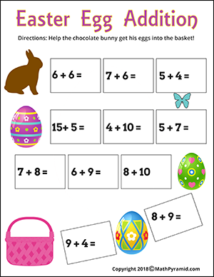](https://www.google.co.uk/url?sa=i&url=https%3A%2F%2Fwww.mathpyramid.com%2Fmath-worksheets%2Feaster-math-worksheets&psig=AOvVaw0E2Qo5KIl2TUHlw2Vgbde1&ust=1585992013604000&source=images&cd=vfe&ved=0CAIQjRxqFwoTCLjiqej2y-gCFQAAAAAdAAAAABBR)

[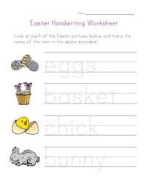](https://www.google.co.uk/url?sa=i&url=https%3A%2F%2Fwww.pinterest.com%2Fpin%2F546905948468946278%2F&psig=AOvVaw0E2Qo5KIl2TUHlw2Vgbde1&ust=1585992013604000&source=images&cd=vfe&ved=0CAIQjRxqFwoTCLjiqej2y-gCFQAAAAAdAAAAABBp)

[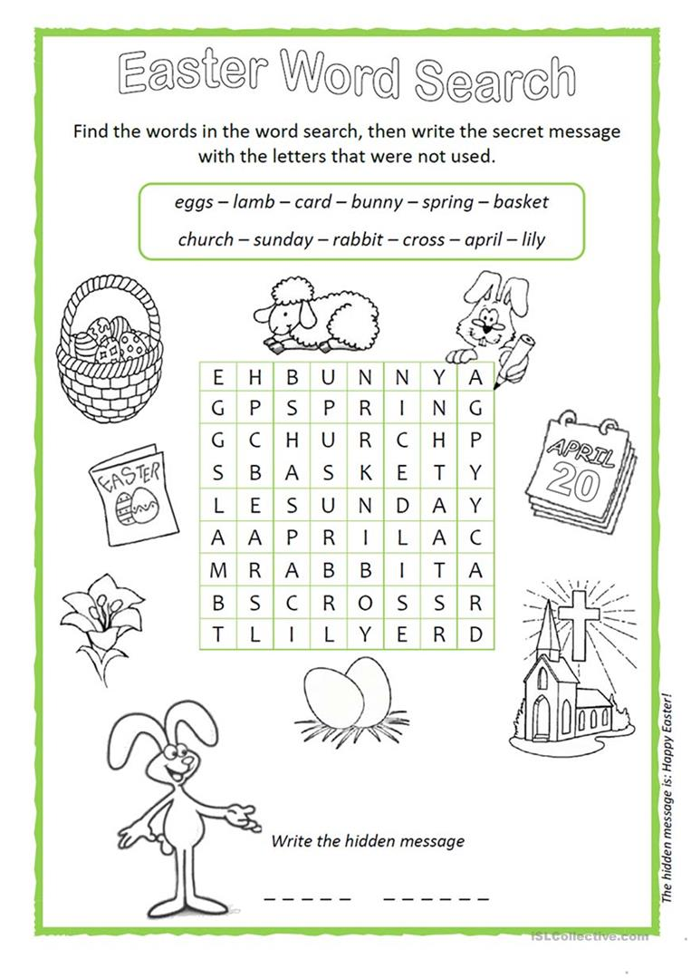](https://www.google.co.uk/url?sa=i&url=https%3A%2F%2Fen.islcollective.com%2Fenglish-esl-worksheets%2Fvocabulary%2Feaster%2Feaster-wordsearch%2F68877&psig=AOvVaw3imreEnk2IdraJCGnBGBA9&ust=1585993898923000&source=images&cd=vfe&ved=0CAIQjRxqFwoTCIiryez9y-gCFQAAAAAdAAAAABAJ)

[](https://www.google.co.uk/url?sa=i&url=http%3A%2F%2Fclipart-library.com%2Fclipart%2F19-ziX4k6j8T.htm&psig=AOvVaw0VSjub_0phP6U9JxezQxaa&ust=1585995058507000&source=images&cd=vfe&ved=0CAIQjRxqFwoTCKDp45WCzOgCFQAAAAAdAAAAABAK)

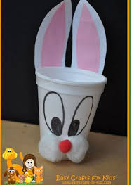

**CRAFT IDEAS….**

[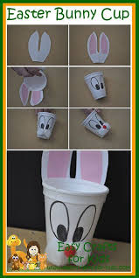](https://www.google.co.uk/url?sa=i&url=https%3A%2F%2Fwww.pinterest.com%2Fpin%2F452189618834632841%2F&psig=AOvVaw2yG1Tvg1xed71RJBjsYA9k&ust=1585994138656000&source=images&cd=vfe&ved=0CAIQjRxqFwoTCNDs4eX-y-gCFQAAAAAdAAAAABAG)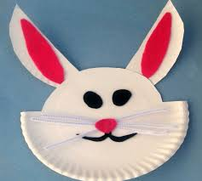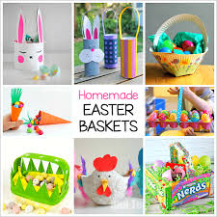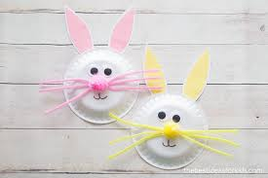

[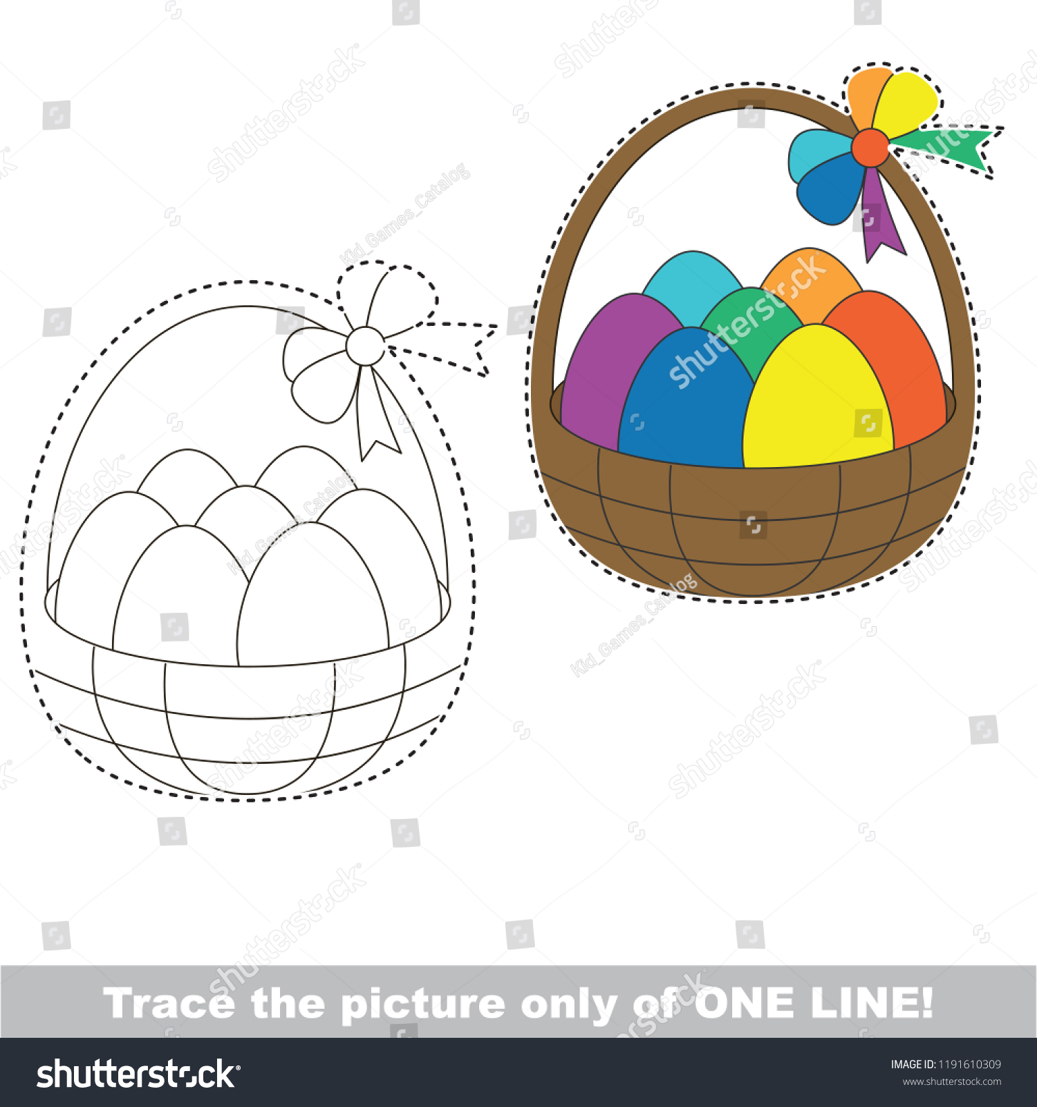](https://www.google.co.uk/url?sa=i&url=https%3A%2F%2Fwww.shutterstock.com%2Fimage-vector%2Fdrawing-worksheet-preschool-kids-easy-gaming-1191610309&psig=AOvVaw1G6-tSFsuOmakRomplkQYA&ust=1585993647871000&source=images&cd=vfe&ved=0CAIQjRxqFwoTCNCZrPj8y-gCFQAAAAAdAAAAABAL)

[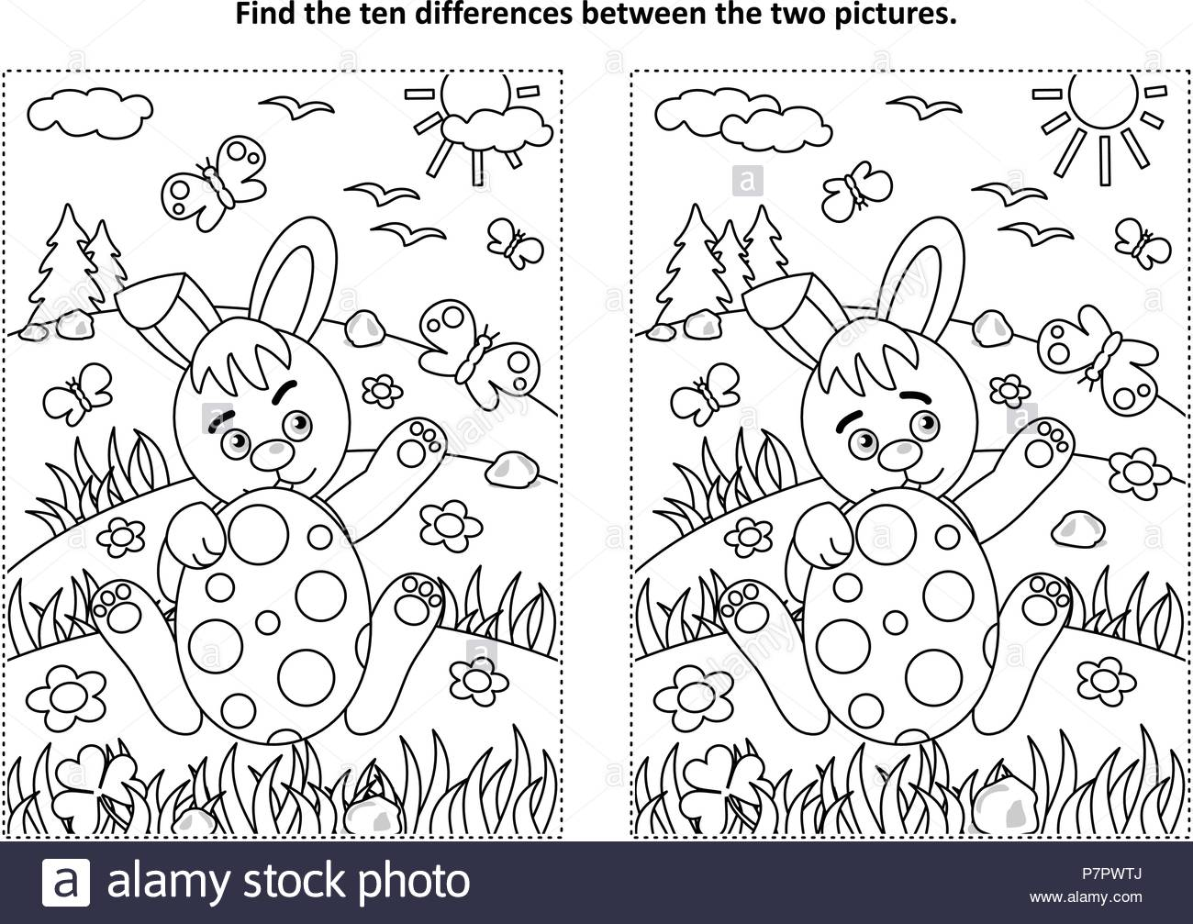](https://www.google.co.uk/url?sa=i&url=https%3A%2F%2Fwww.alamy.com%2Feaster-holiday-themed-find-the-ten-differences-picture-puzzle-and-coloring-page-with-bunny-and-painted-egg-rural-scene-image211330242.html&psig=AOvVaw31_om5i5UPuHRYvM5KSkCz&ust=1585993433446000&source=images&cd=vfe&ved=0CAIQjRxqFwoTCMiu3I78y-gCFQAAAAAdAAAAABAD)

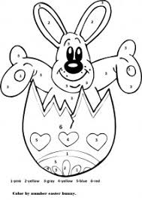

[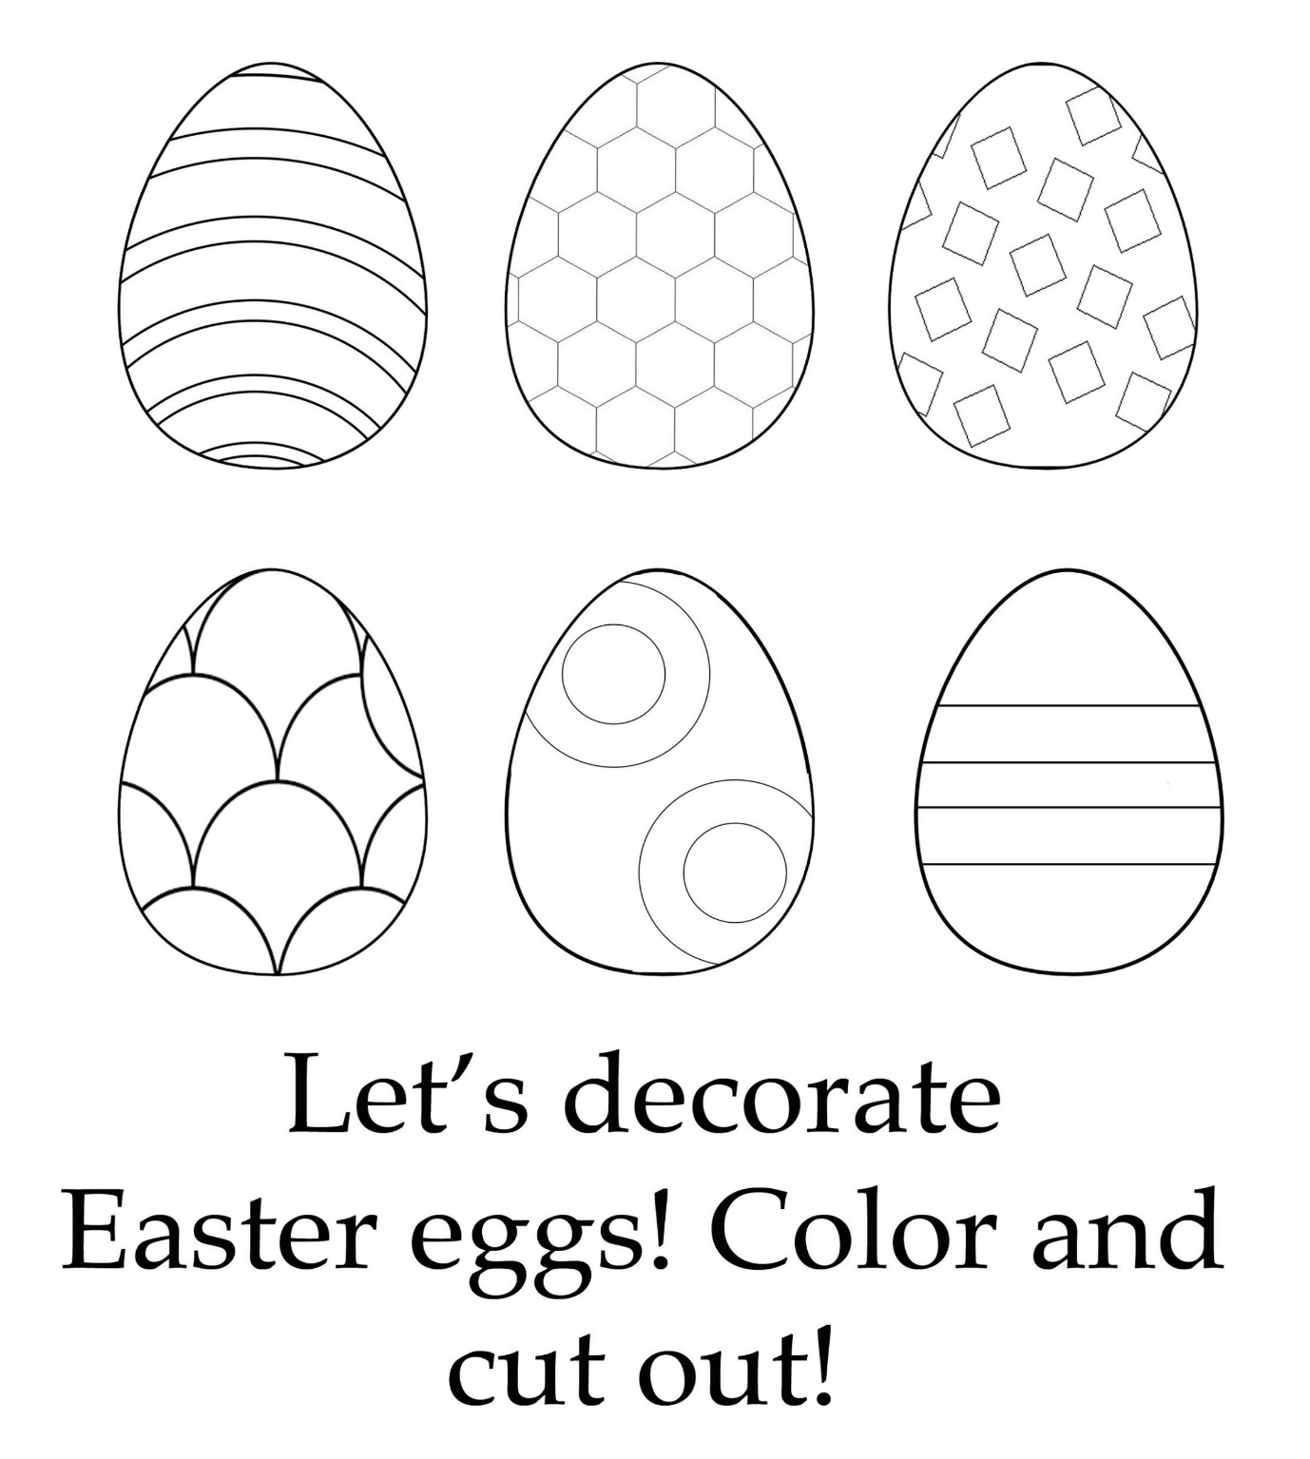](https://www.google.co.uk/url?sa=i&url=http%3A%2F%2Fmarchonthepolls.org%2F63pV8t5H%2FxM8380jS%2F&psig=AOvVaw2dE5m438jKNQkJBvmBL6bd&ust=1585992647443000&source=images&cd=vfe&ved=0CAIQjRxqFwoTCJiI7pf5y-gCFQAAAAAdAAAAABAh)

[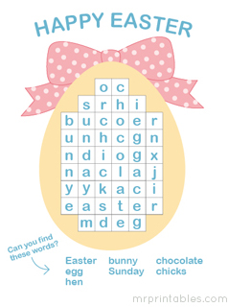](https://www.google.co.uk/url?sa=i&url=https%3A%2F%2Fmrprintables.com%2Fprintable-word-search-puzzles.html&psig=AOvVaw3OJSD87DctFlaS8uu7m7wS&ust=1585993309666000&source=images&cd=vfe&ved=0CAIQjRxqFwoTCOirwtX7y-gCFQAAAAAdAAAAABAG)

[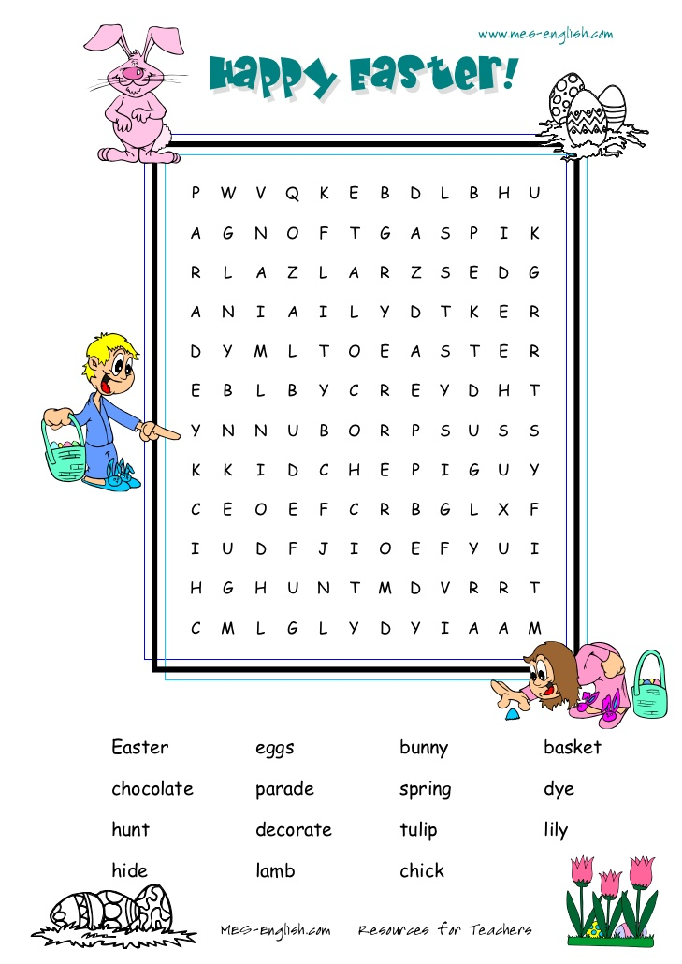](https://www.google.co.uk/url?sa=i&url=https%3A%2F%2Fpt.slideshare.net%2FLjubicaPetkovska%2Feaster-wordsearch&psig=AOvVaw0VSjub_0phP6U9JxezQxaa&ust=1585995058507000&source=images&cd=vfe&ved=0CAIQjRxqFwoTCKDp45WCzOgCFQAAAAAdAAAAABAV)

[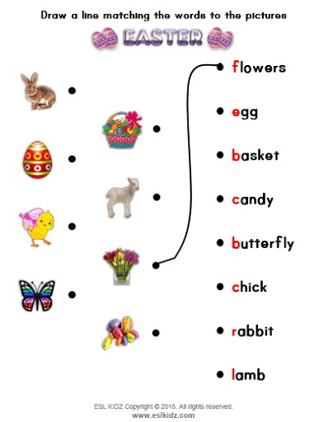](https://www.google.co.uk/url?sa=i&url=http%3A%2F%2Fwww.eslkidz.com%2Feaster.html&psig=AOvVaw0VSjub_0phP6U9JxezQxaa&ust=1585995058507000&source=images&cd=vfe&ved=0CAIQjRxqFwoTCKDp45WCzOgCFQAAAAAdAAAAABAb)

[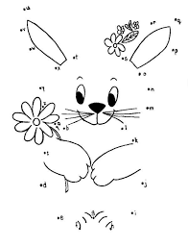](https://www.google.co.uk/url?sa=i&url=https%3A%2F%2Fwww.pinterest.com%2Fpin%2F541557923927582878%2F&psig=AOvVaw3E0143ZGDjq_ifgq-fhicv&ust=1585997499337000&source=images&cd=vfe&ved=0CAIQjRxqFwoTCOCLh6qLzOgCFQAAAAAdAAAAABAS)

[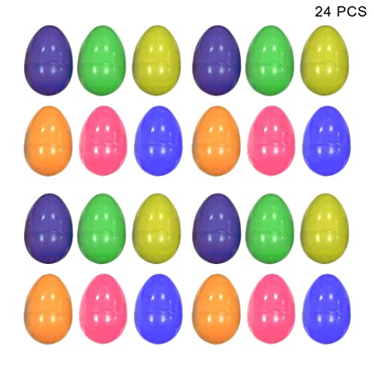](https://www.google.co.uk/url?sa=i&url=http%3A%2F%2Fwww.danceumbrella.co.uk%2FOther-Gift-amp%3B-Party-Supplies-o320881-%26-Party-Supply-Fillable-Easter-Eggs-Coloured-Plastic-Surprise-Egg%2F&psig=AOvVaw1Ou-zcCYsL83cKU-qrycM7&ust=1585997114016000&source=images&cd=vfe&ved=0CAIQjRxqFwoTCJi09OuJzOgCFQAAAAAdAAAAABAZ)

Cut these out and hide them around the garden



**Paint eggs…**

[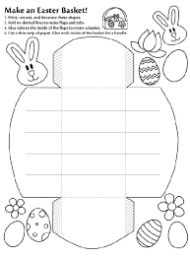](https://www.google.co.uk/url?sa=i&url=https%3A%2F%2Fwww.pinterest.com%2Fpin%2F444660163184515695%2F&psig=AOvVaw1kCylASxduVV2tqwXGEfz2&ust=1585999541909000&source=images&cd=vfe&ved=0CAIQjRxqFwoTCIjKxvCSzOgCFQAAAAAdAAAAABAb)

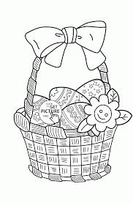

[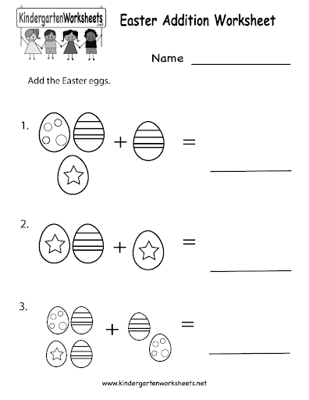](https://www.google.co.uk/url?sa=i&url=http%3A%2F%2Fwww.preschoolactivities.us%2Feaster-worksheet-for-kids%2Feaster-addition-worksheet-printable%2F&psig=AOvVaw2Z9TZCDFoKekenL9-ngbvl&ust=1586000648013000&source=images&cd=vfe&ved=0CAIQjRxqFwoTCNi51v6WzOgCFQAAAAAdAAAAABAz)

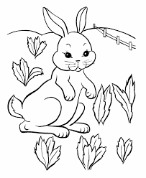

[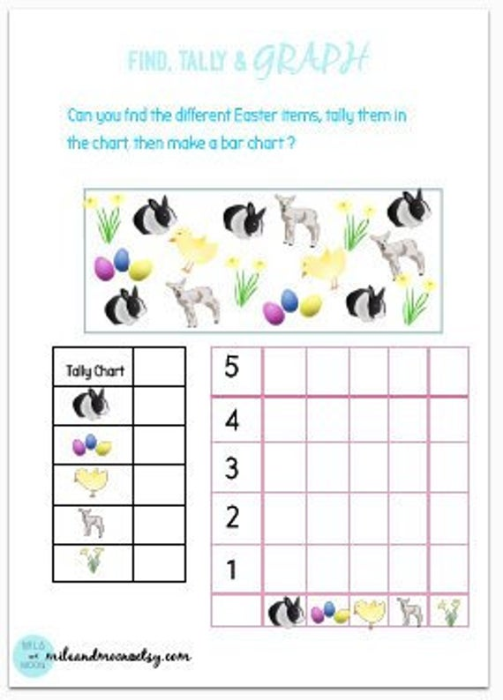](https://www.google.co.uk/url?sa=i&url=https%3A%2F%2Fwww.etsy.com%2Flisting%2F693294157%2Finstant-downloadeaster-numeracy-activity%3Fref%3Drelated-4&psig=AOvVaw2Z9TZCDFoKekenL9-ngbvl&ust=1586000648013000&source=images&cd=vfe&ved=0CAIQjRxqFwoTCNi51v6WzOgCFQAAAAAdAAAAABAK)

[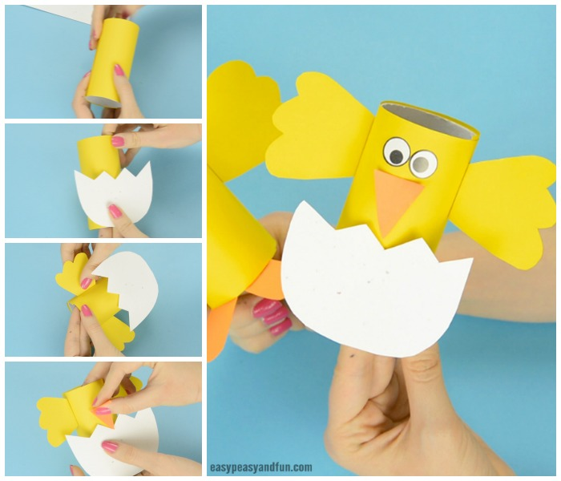](https://www.google.co.uk/url?sa=i&url=https%3A%2F%2Fwww.easypeasyandfun.com%2Fchick-toilet-paper-roll-craft%2F&psig=AOvVaw2Jota1ASSSSEEdwV-4z2WR&ust=1586000517813000&source=images&cd=vfe&ved=0CAIQjRxqFwoTCMjckcOWzOgCFQAAAAAdAAAAABAD)

Get your toilet paper, glue and colour in some paper for wings.

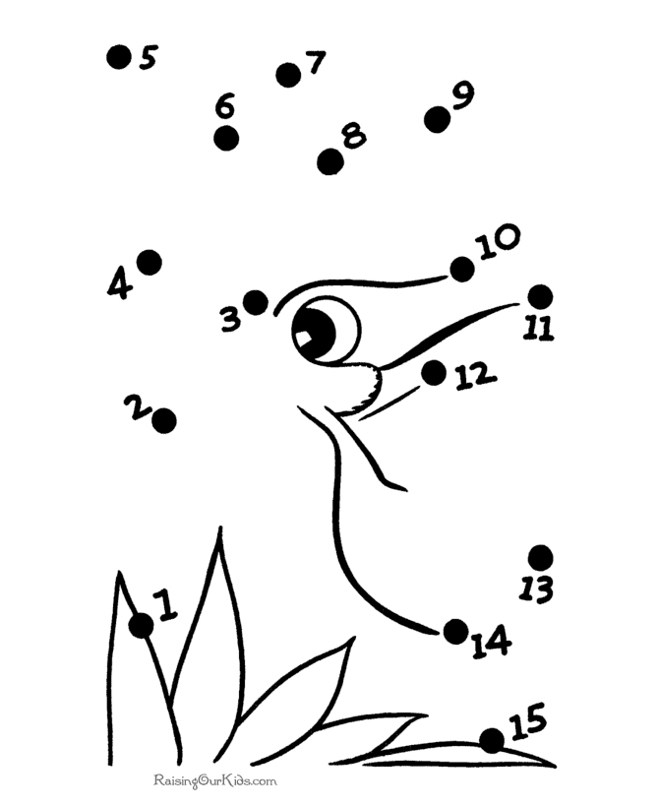

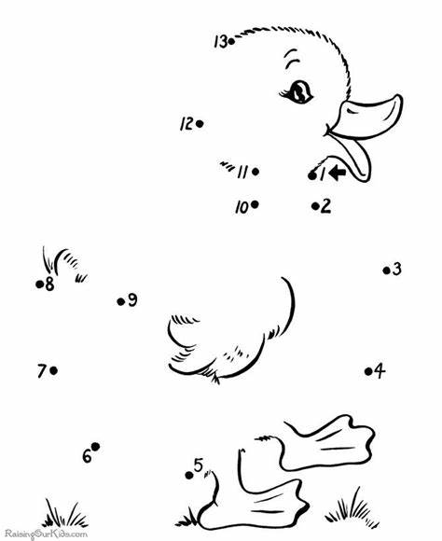

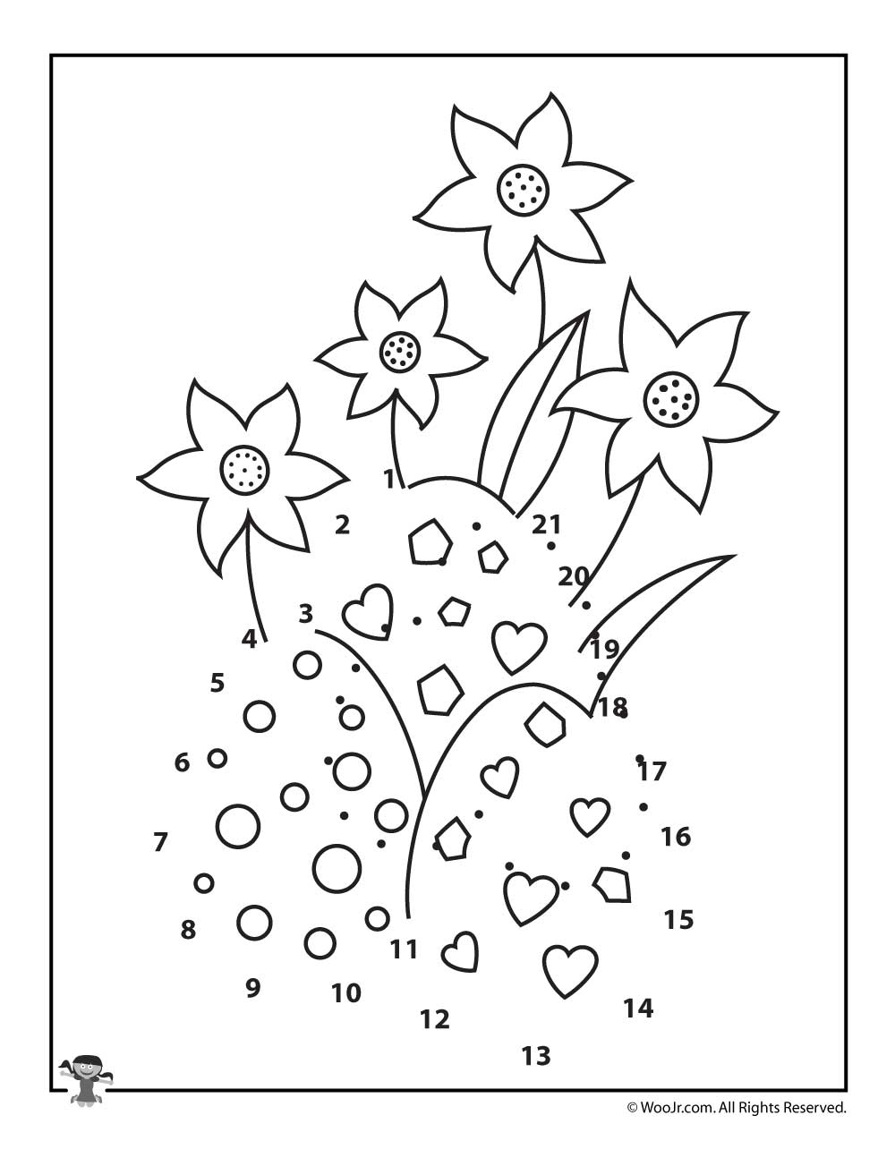

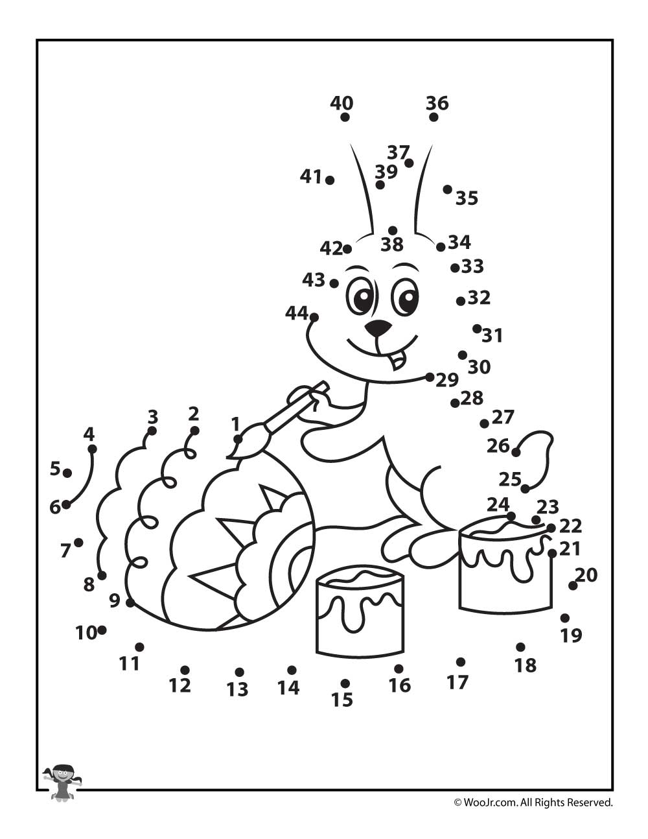

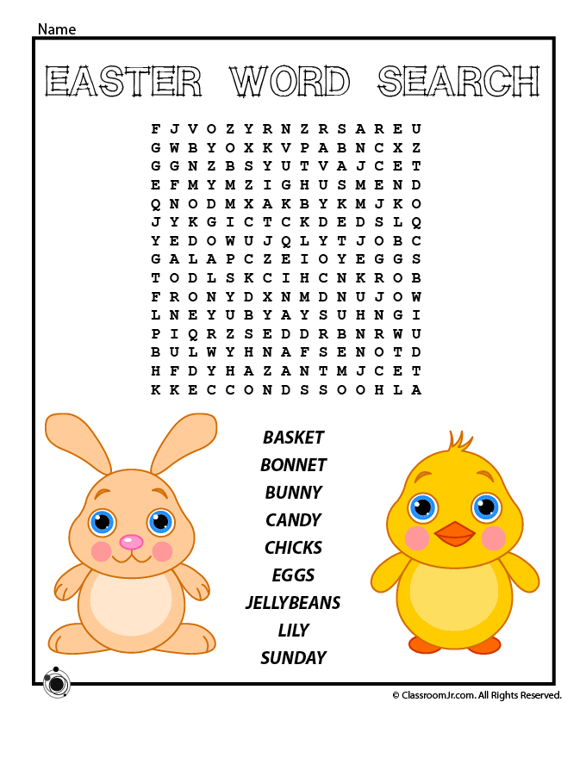

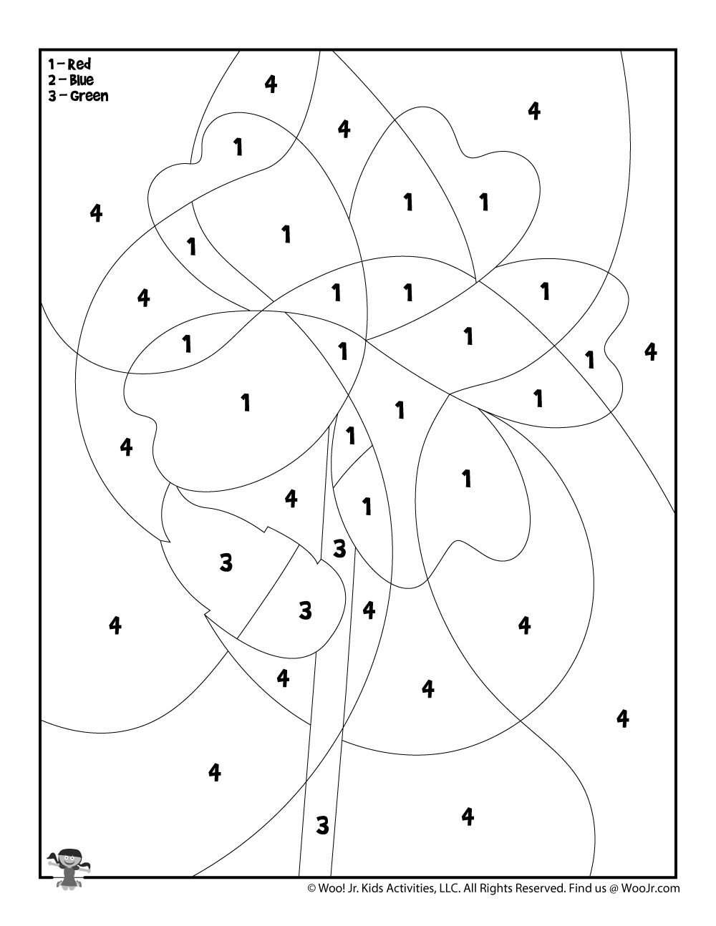

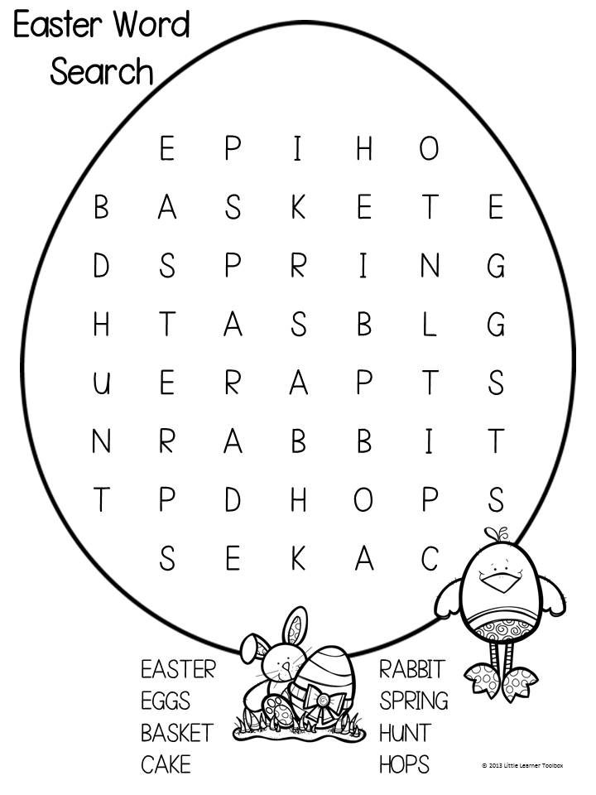

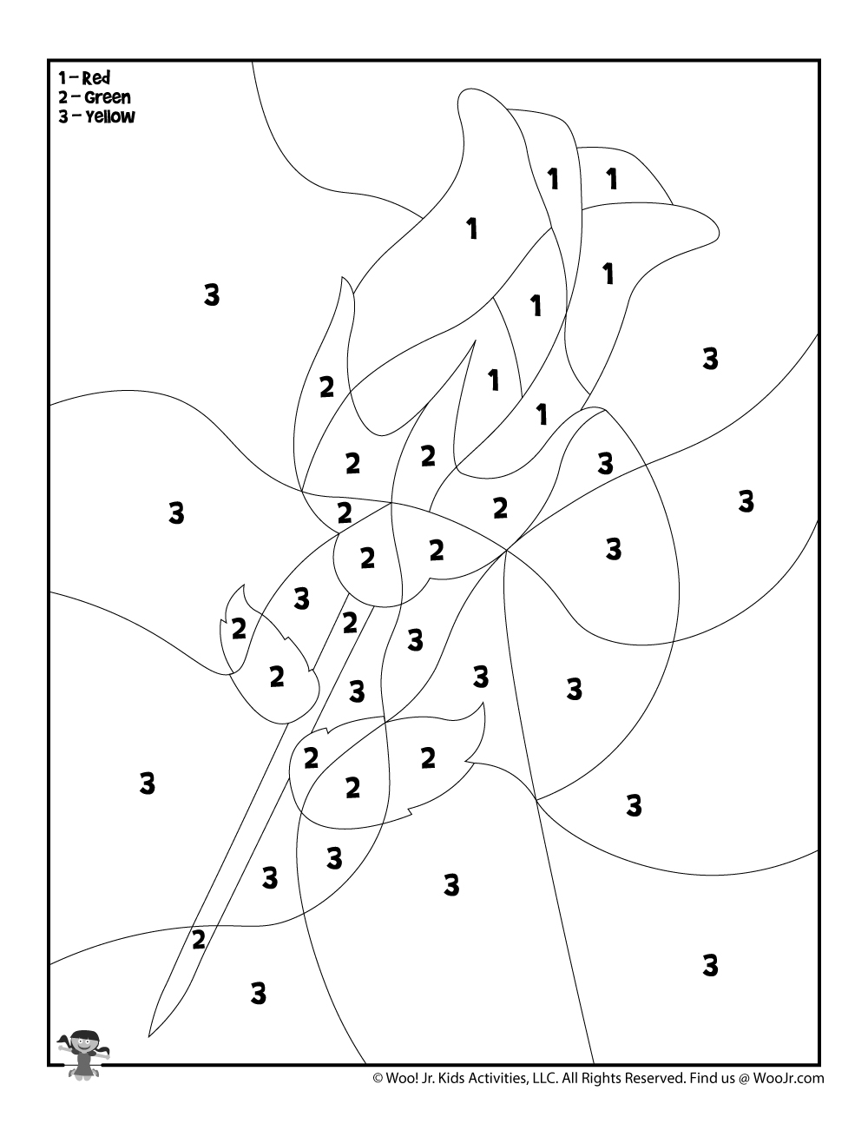

[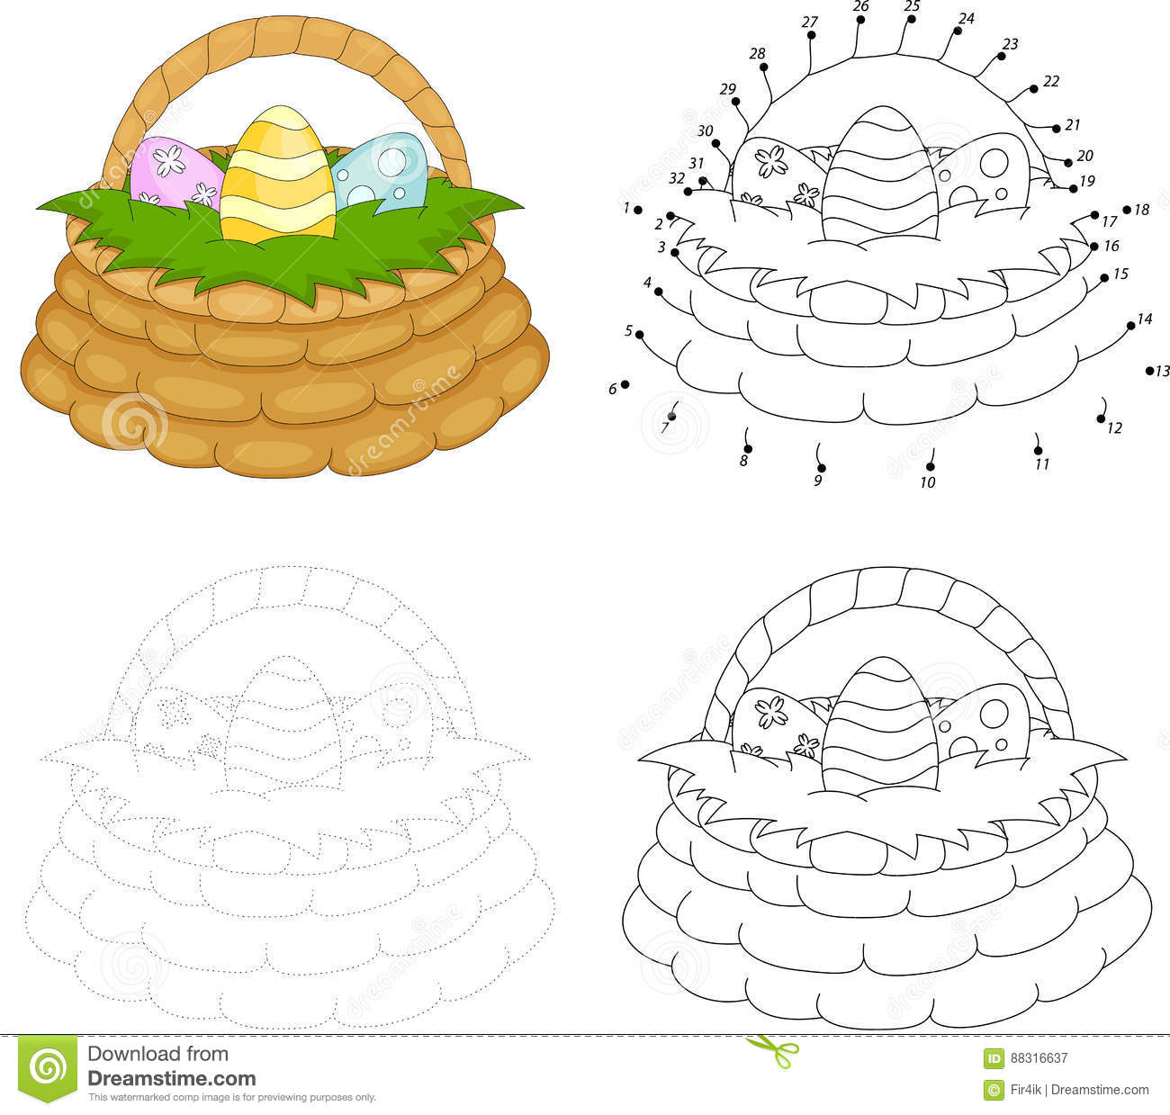](https://www.google.co.uk/url?sa=i&url=https%3A%2F%2Fwww.dreamstime.com%2Fstock-illustration-cartoon-basket-easter-eggs-dot-to-dot-game-kids-educational-image88316637&psig=AOvVaw3E0143ZGDjq_ifgq-fhicv&ust=1585997499337000&source=images&cd=vfe&ved=0CAIQjRxqFwoTCOCLh6qLzOgCFQAAAAAdAAAAABAZ)

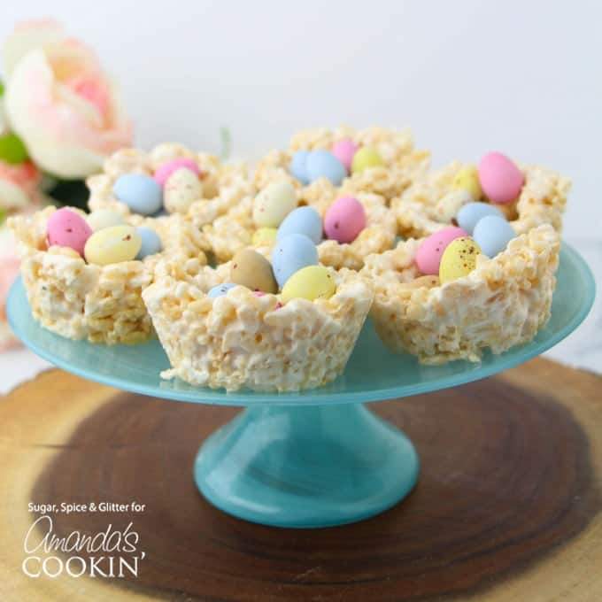

**Ingredients to Make Rice Krispie Nests**

4 cups marshmallows

5 cups rice cereal

1/4 cup coconut oil (or butter)

2 teaspoons vanilla

2 cups mini eggs

**Helpful Kitchen Tools**

[Large microwave-safe bowl](https://amzn.to/2pe7Ppm)

[Spatula](https://amzn.to/2mTdsJY)

[Measuring cups and spoons](https://amzn.to/2mfuX48)

[Muffin pan](https://amzn.to/2miAacT)

**Instructions**

Grease a 12-cup muffin tray and set aside.

Place the marshmallows in a large microwave-safe bowl and heat for 25-30 seconds. Stir well, and repeat heating as needed.

Add the melted coconut oil and vanilla extract to the marshmallows and stir well to incorporate.

Add the rice cereal cup at a time, gently folding it into the marshmallow mixture, until all of the cereal is incorporated.

Scoop heaping 1/4 cup portions of the rice krispie treats into the prepared muffin tray.

Wet your hands and press the rice krispies into a cup or tart-shape.

Place in the fridge for 2 hours or overnight to set.

When the nests have had a chance to set and harden, pop them out of the muffin tray using a butter knife and fill with treats. We used mini eggs but jellybeans or a some berries would also be delicious.

Lets bake:

[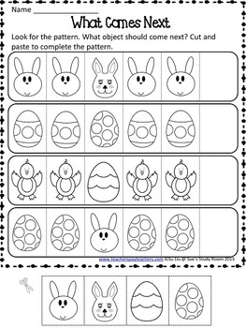](https://www.google.co.uk/url?sa=i&url=https%3A%2F%2Fwww.teacherspayteachers.com%2FProduct%2FEaster-Patterns-Worksheets-1772953&psig=AOvVaw3TLCqZavLuwkonAO3cLQU3&ust=1585999209951000&source=images&cd=vfe&ved=0CAIQjRxqFwoTCIC7qtCRzOgCFQAAAAAdAAAAABAJ)

[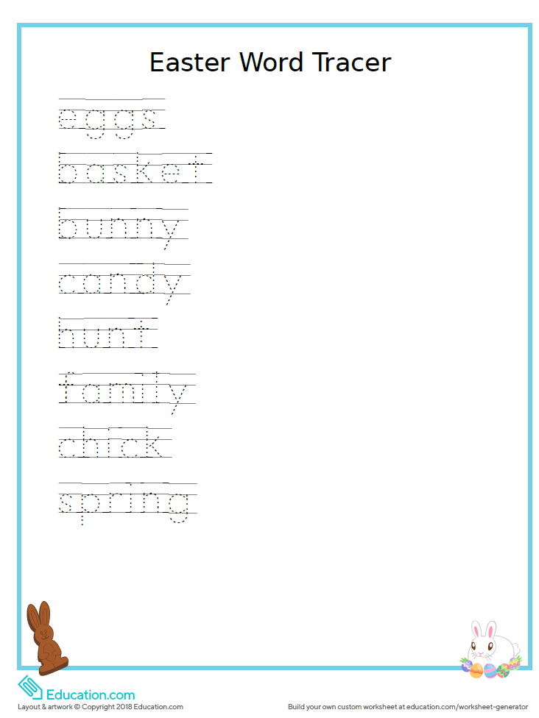](https://www.google.co.uk/url?sa=i&url=https%3A%2F%2Fthetwentyishmum.com%2F2019%2F04%2F16%2Feaster-worksheets-education-com%2F&psig=AOvVaw3TLCqZavLuwkonAO3cLQU3&ust=1585999209951000&source=images&cd=vfe&ved=0CAIQjRxqFwoTCIC7qtCRzOgCFQAAAAAdAAAAABAP)

[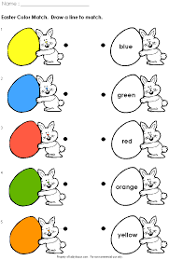](https://www.google.co.uk/url?sa=i&url=https%3A%2F%2Fwww.pinterest.com%2Fpin%2F405605510166524832%2F&psig=AOvVaw3TjcamLLBW32wl3gg8221J&ust=1585999343903000&source=images&cd=vfe&ved=0CAIQjRxqFwoTCNiNspCSzOgCFQAAAAAdAAAAABAD)

[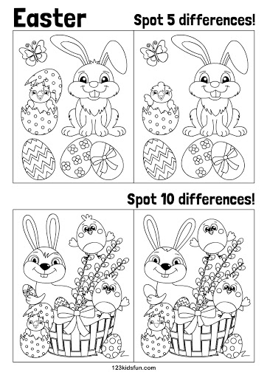](https://www.google.co.uk/url?sa=i&url=http%3A%2F%2F123kidsfun.com%2Feaster%2F&psig=AOvVaw3TjcamLLBW32wl3gg8221J&ust=1585999343903000&source=images&cd=vfe&ved=0CAIQjRxqFwoTCNiNspCSzOgCFQAAAAAdAAAAABAJ)

[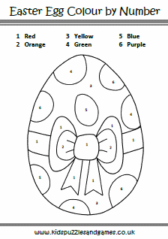](https://www.google.co.uk/url?sa=i&url=https%3A%2F%2Fwww.kidspuzzlesandgames.co.uk%2Fpuzzle-sheets%2Feaster-puzzle-sheets%2Feaster-egg-spotted-text-colour-by-numbers&psig=AOvVaw3TjcamLLBW32wl3gg8221J&ust=1585999343903000&source=images&cd=vfe&ved=0CAIQjRxqFwoTCNiNspCSzOgCFQAAAAAdAAAAABAW)

[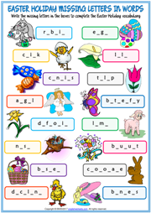](https://www.google.co.uk/url?sa=i&url=https%3A%2F%2Fwww.englishwsheets.com%2Feaster.html&psig=AOvVaw3TjcamLLBW32wl3gg8221J&ust=1585999343903000&source=images&cd=vfe&ved=0CAIQjRxqFwoTCNiNspCSzOgCFQAAAAAdAAAAABAe)

[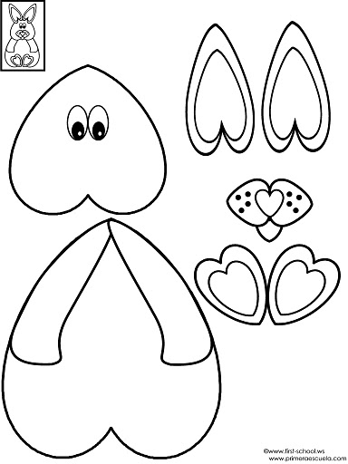](https://www.google.co.uk/url?sa=i&url=http%3A%2F%2Fwww.preschoolactivities.us%2Fcut-paste-crafts-for-kidsbw-template%2Fcut-paste-bunny%2F&psig=AOvVaw1kCylASxduVV2tqwXGEfz2&ust=1585999541909000&source=images&cd=vfe&ved=0CAIQjRxqFwoTCIjKxvCSzOgCFQAAAAAdAAAAABAU)

Cut out and see what you find

