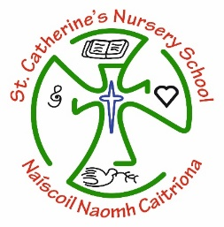
Nursery Graduation

Dear Parents and Children
It is with great pride we sit to write this Graduation letter. However, this year it is tinged with some sadness as we did not get to complete our school year in the way we had planned.
In September we met each of you with smiles on your little faces and high hopes for the year that lay ahead of us all. At no point did any of us expect to have to end our school year early due to the unprecedented circumstances that we all found ourselves in due to Covid19.
In the shortened time we had together we got to watch you all grow and form friendships. Each day, a new experience was knowledge gained, skills acquired and another steppingstone in getting you ready for Primary 1. You all had your favourite areas of the classroom – some enjoyed play at the water tray, others got to show off their creativity at junk art and some boys and girls liked the quietness of story time. We will not forget how proud you made us feel when you shone in your Christmas Show. You really were all little stars and angels.
However we have to look at the brighter side of the times we are living in and appreciate all the quality family time you have had together. You have all worked so hard from home. We have just loved seeing all of the photographs that have been sent in of you working hard, it makes us so happy to see all of the things that you have been up to.
As this, your Nursery year comes to a close, you are a few inches taller, cleverer, and ready to move on to Primary 1. We have missed seeing you all in school, singing our songs and saying our rhymes.
At this time, we would be busy preparing for our very Special Graduation ceremony. However, this year is different, but it is still a very important part of Nursery.
It is for this reason we want to let you know how we will mark your Graduation on 3rd June 2020.
- A specially prepared film will be posted on social media which will have your photos and names included and will be a tribute to you all on that day. Please watch out for it on our St Catherine’s PS School Facebook platform.
- A graduation booklet and your child’s Graduation Scroll will be emailed out to every family on this day.
This is just for now, until we meet again and celebrate together in the future. For now, enjoy your summer holidays and good luck when you begin your year in Primary 1.
Congratulations,
From Mrs. Wilders, Miss Doherty, Mrs. Porter, Mrs Mc Corkell, Mrs. Caulfield, Mrs Campbell, Ms. Porter, Mrs Mc Daid, Mrs Cooke and everyone in our school family

