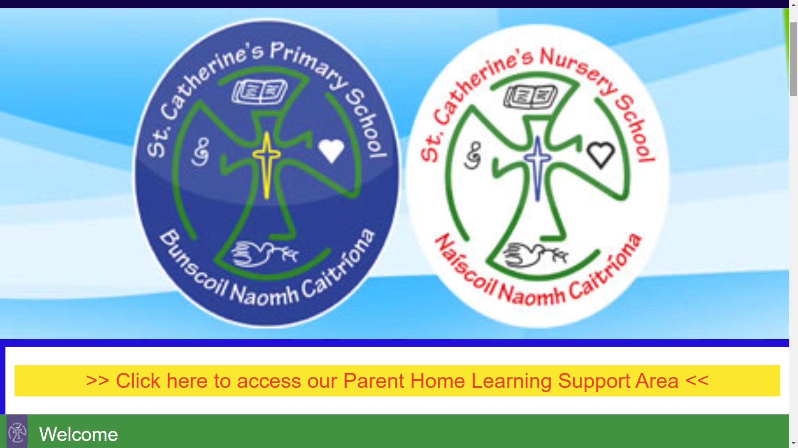
St Catherine’s Website: How to Use the Parent Home Learning Activities.
Welcome to our Parent Home Learning Support Area. We hope that you will find this useful both for yourselves and ultimately your children. Please feel free to explore the range of links here to various learning sites for ideas for Home Learning, support while Home Learning, games that can be played by and with children and some simple lesson ideas that can be taught.

In each Year Group, Staff have prepared a little plan for learning (for the next 6 weeks) in this exceptional circumstance to try to guide Home Learning in the absence of your child being at school to have it explained directly to them.
Use these resources in conjunction with the other links to websites and apps to continue with Home Learning. Remember nothing can replace the teacher or school environment so Home Learning is never going to be the same as school…this is a new way because of the emergency situation we find ourselves in. We must try to adapt to this as best as we can.

You are also not expected to use all of the resources here at all. These are only ideas and because we are all such individual learners, some of these will work for us and some will not.
Points to note;
- These links to learning sites/apps can be just a different way of learning and practising some things.
- Videos/podcasts can be fun to watch.
- Worksheets can be downloaded, printed off and completed for practice at home only if you can however these worksheets DO NOT HAVE TO BE PRINTED, but can also be used as the children would use text books/ whiteboard in school to read through or copy down.
- Some activities, eg wordsearches, comprehensions can be read through and answered orally rather than having to write them down or if you wish to copy down from the screen, this will give your child HANDWRITING PRACTICE!
- There are links to PowerPoints, You-tube links and videos to help teach the topics as well.
- Online educational games can be fun and can be used to help teach the topic.
- When the children are working off the screen on their ipad/ laptop etc. there is no better way to develop their Computer Skills , Digital Technology Awareness, IT Skills and keyboard skills.
- Practical Activity suggestions can be tried at home with an idea for learning but most of all just for fun.
- Reading- keep your child reading as much as possible as this is invaluable!
- Free Play and independent imaginative play is crucial especially for younger children.
- Meditation links and links to our Grow in Love Spiritual Religious Programme can soothe our children and help them make sense of the world especially when they are anxious….do not be afraid to use them. This is very important for well being.

Remember you cannot do it all- you should not even attempt that. You know your child best; simply do your best together!

