St. Catherine’s Primary School
Principal: Mrs Bridget Wilders B.Ed. P.G. Dip.Ed. P.Q.H.
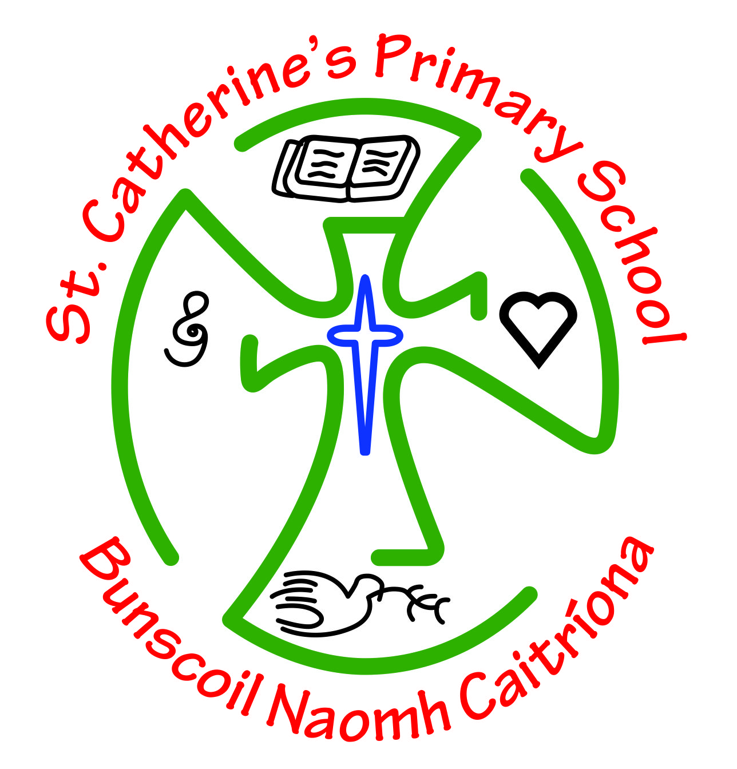

Junior School Senior School
Newtownkennedy St. Site Barrack St. Site
Strabane Strabane
Co.Tyrone Co. Tyrone
BT82 8HT BT82 8HE
Phone:02871382272 Phone: 02871 382614
Fax:02871 382139 Fax: 02871 382482
Email: bwilders592@c2kni.net
www.stcatherinesps.co.uk
Download our FREE APP : St Catherines PS,Strabane
Find us on Facebook: StCatherines PrimarySchool
Follow us on Twitter : StCatherinesPS
Follow us on Instagram : St Catherine’s Primary School

Keeping in Touch!!
Dear Parents,
As you are aware we have launched our NEW HOME LEARNING AREA on our website www.stcatherinesps.co.uk which can be accessed by typing in your password which has been texted out to you!
We miss you all so much and we want to keep in touch with you to answer any queries you might have about the work in the Home Learning Area or any queries or concerns you have about anything at all. These are indeed strange times and everyone of us are facing challenges and fears that we never thought we would have to face, so don’t feel alone in this…we are here to reach out to and if we can help, we will.
To that end we will be communicating with you via the usual methods;
1. Text Messaging
2. Social Media (Facebook, Twitter, Instagram)
3. Website (Very important now for Home Learning in Term 3)
4. School App

BUT IN ADDITION TO THIS;
1. Staff may be giving you a wee phone call over the next week or so just to check in and get a chat …this will register as a PRIVATE NUMBER, so don’t be alarmed!
2. Staff emails will be sent to you via text message and also written in the Parents Instructions How To Use This Area Sheet in each Home Learning Year Group Area on the website so you can email them with any queries also; and they will respond you as soon as is possible.
3. Principal’s email is bwilders592@c2kni.net and Vice Principal’s email is jdoherty742@c2kni.net which you can also use to communicate.

Hopefully you are all keeping safe and well,
Mrs Wilders (Principal)

